What is the effect of crowd support on team performance and home advantage?

**An analysis of the influences of “ghost games” on home advantage**



1. Rijnders (**2063482**)

04-06-2021

MSc Marketing Analytics

Tilburg School of Economics and Management

Tilburg University

Master Thesis Supervisors:

1. van der Plas MSc

Dr. A.I.J.G. van Lin (co-reader)

Management Summary

The notion of home-advantage is a widely studied concept in sports related academic literature. Crowd support is considered to be one of the major drivers of team performance and home advantage in sports. However, the effect of crowd support on home advantage and team performance is difficult to directly assess. We used the extraordinary situation in which all matches across major European football leagues were played behind closed doors following the covid-19 pandemic to directly assess the impact of crowd support on team performance.

We enriched the analysis by looking into the effect of several moderating variables namely, the average age of players, the number of foreign players in the squad, the absolute crowd size and the occupacny rate. Furthermore, we assessed to what extent the influence of crowd support on team performance is mediated by a referee bias in favour of home teams. We used a structural equation model to perform a moderated mediation analysis to assess the influence of crowd support on team performance. We incorporated referee bias as a latent construct comprising of differences in fouls and yellow cards for home and away teams. In goal difference and points difference we used 2 different measure of team performance as dependent variables.

We found that crowd support significantly affects team performance for both home and away teams. Part of this effect is mediated by a referee bias for the home team. Furthermore, we found evidence that rather than absolute crowd size, the occupancy rate plays a major role in the size of the effect of crowd support on team performance. For high levels of crowd occupancy the difference in points and goals was .514 and .737 whereas for low levels of occupancy the gpa only decreased by .197 for goals and .339 for points. We found no evidence for a significant influence of team age and team composition on the relationship between crowd support and team performance.

Based on these findings marketing managers know that the importance of a filled stadium lies beyond the extra revenue associated with more fans. Higher occupancy levels can mean the difference between qualifying for european football or not or the difference between staying up in the highest division and relegation, both with immense financial consequences. Additionally, this implies that decisions such as moving to a new stadium should only be taken when you are really sure to be able to fill the stadium as much as the current stadium.

Preface

In front of you lies the thesis “*What are the effects of crowd support on team performance and home advantage”*, which aimed to understand the influence of crowd support on team performance and referee decsision making. This thesis was written as the final step of completing the master program

Marketing Analytics at Tilburg University, Tilburg School of Economics and Management. The

process of writing this thesis has engaged me from February 2021 to June 2021.

This thesis was written under supervision of Joep van der Plas, who introduced me to this

topic. The process of writing this thesis has been challenging. Fortunately, Joep van der Plas

was always very helpful during the meetings and provided excellent feedback to help me through the process of writing this thesis.

I would like to thank Joep van der Plas for the excellent guidance throughout the process. I also would like to thank my parents, friends, and for their support and motivational words.This thesis will not be my final chapter at Tilburg University, as I am looking forward towards my participation in the QTEM program, for which I am very thankful for the opportunity given by Tilburg University. I hope you enjoy reading my master thesis

Alan Rijnders

Tilburg, June 4th, 2021

Table of contents

1 Introduction 5

1.1 Problem Indication 5

1.2 Research Approach 7

1.3 Academic Relevance 7

1.4 Managerial Relevance 8

1.5 Structure of the Thesis 9

2. Theoretical Background 10

2.1 Literature Review 10

2.1.1 Crowd support and home advantage 10

2.1.2 Team composition and home advantage 12

2.1.3 Covid-19 and home advantage 13

2.2 Conceptual Framework 14

2.2.1 The impact of crowd support on team performance 14

2.2.2 The impact of crowd support on referee bias 16

3. Data and Methodology 18

3.1 Data collection 18

3.2 Variable Operationalization 19

3.3 Descriptive statistics 22

3.4 Home advantage pre and post covid-19 22

3.5 Model 28

4. Analysis and Findings 29

4.1 Assumptions 29

4.2 Results overview 30

4.3 Robustness check 33

4.4 Moderating effect occupancy 35

5. Conclusion and Discussion 36

5.1 Conclusions 36

5.2 Managerial recommendations 38

5.3 Limitations and areas for future research 39

5.4 Final overview 40

6. Bibliography 40

7. Appendix 45

# Introduction

## Problem Indication

Football is the most popular sport in the world with millions of players across the Globe. According to a study conducted by FIFA (2006), the amount of active football players was 265 million (FIFA 2007). In other words, roughly 4 percent of total world population at that time was regularly playing football. The amount of fans is even more staggering, with 3.5 billion people tuning in for the FIFA World Cup Final in 2018 between France and Croatia for example (FIFA, 2019). Many of these fans were left without their favourite pastime for a considerable time when the Covid pandemic struck Europe and other parts of the world in March 2020. Due to strict measures and even complete lockdowns in several countries almost all sports games were postponed until further notice. After a few months of lockdown, the Bundesliga was the first major league to restart on the 16th of May featuring 6 matches behind closed doors. Other major European leagues such as the Premier League, Serie A and La Liga followed soon. Global social distancing measures following the Covid-19 pandemic introduced the phenomenon “Ghost Matches”; football matches without any spectators attending. Without the fans attendance the matches seemed mere training games. Some surprising results in favour of away teams in the first few weeks following the restart renewed interest in the role of crowd support and home advantage.

Thanks to footballs worldwide popularity, an abundant base of research on the possible advantage for teams playing at home existst. Goumas (2014) finds that home teams on average win more games, collect more points and score more goals than away teams. Goumas’ (2014) findings resonate with results from earlier studies such as those conducted by (Clarke & Norman 1995 ; Pollard, 2006; Pollard & Gomez, 2009). All studies found a persistent advantage for teams playing at home across countries and time. However, the exact source of home advantage and the role of crowd support herein remains debatable. Pollard & Polla[rd (2005](https://shapeamerica.tandfonline.com/doi/full/10.1080/02640410601038576?scroll=top&needAccess=true)) for example negate the role of crowd support in the formation of home advantage whereas Smith (2003) argues that the performance boost for home teams as a consequence of crowd support as the main driver of home advantage. Crowd support also could affect match outcome through referees decision. Neville & Holder (1999) and Bokyo (2007) find that crowds could influence referee decisions subconsciously in favor of the home team. This is favoritism is often named the “referee bias”. A term we will use as well in our research from now on. Endrich & Gesche (2020) quantify the referee bias in their paper where they find that away teams on average receive 0.3 cards less and home teams 0.5 cards more per match when there are no spectators.

Home advantage seems to be declining over time generally.(Peeters & van Ours, 2021). One of the major factors behind this decline to is the bigger distance between fans and players, with most of the players coming from countries spread around the world, presumably less connected to the local fans who are used to supporting their local heroes. (Pollard 2006; Smith 2003).This aspect of crowd support and home advantage has been overlooked in the literature. Therefore, we use this unique situation to assess the extent to which potential distance between fans and players impacts crowd support and team performance.

To summarize, opinions on how and to what extent home advantage is shaped by crowd support are very mixed. Considering the uncertainty regarding the effect of crowd support, the current extraordinary circumstances thus provide a special occasion to increase our understanding of the relevance of crowd support and its influence on referee behaviour and player performance. Furthermore, the effect of moderating variables such as the composition of teams in terms of foreign and local players, crowd size, team age and crowd occupancy on team performance can be directly investigated.

## Research Approach

Providing meaningful insights into the role of crowd support requires a combination of theoretical and empirical analysis. Firstly, we examine the current and historical literature to obtain a view on the current knowledge on the relationship between crowd attendance and team performance. This will serve as our basis on which we can conduct the right analytical approach to analyze our data.We decide to include the seasons 2018/19, 2019/20 and 2020/21 into our final analysis. Around 2018, the VAR got introduced in most of the matjor league in Europe, possibly changing our results on referee behaviour significantly.We then combine match data with a dataset from Fivethirtyeight to incorporate team strength and match importance which we include as control variables into the analysis. The data for our moderator variables, team age, amount of foreigners and stadium occupancy are collected manually from Transfermarkt.com. This website provides a vast amount of detailed statistics on players, clubs and leagues.

## Academic Relevance

The batch of matches without fans provides an unique opportunity to delve deeper in the impact of crowds on football matches since there is an abundance in new data for matches played without crowds. Past papers often required advanced econometric techniques, relying on various assumptions, to be able to discern the extent to which a crowd influences home team advantage. The difficulties in assessing drivers of home advantage lies in confounding variables effects (Pollard , 2008). This makes it unclear how much of home advantage can be attributed to what factors since most of the factors of home advantage are connected to each other. However, in the current situation, suddenly there are substantial amounts of data on “ghost games” which can be used to directly compare matches with and without spectators, which reduces the number of assumptions to be made significantly.

A few papers on home advantage in times of covid-19 have been published already, including the work of (Fischer & Haucap, 2020;Deutscher & Winkelmann, 2020; Endrich & Gesche, 2020). They analyzed the home advantage during the covid-19 pandemic. However,each of these papers focused on German leagues in their analysis. We add to the current research by extending the preliminary research already completed to numerous other football leagues to obtain a comprehensive overview of the evolution of home advantage during the pandemic. Also compared to preliminary studies on home advantage, in our paper we use the extended availability of data for games played behind closed doors available in the 2020/21 season. Papers from last year mostly use data from the 2019/2020 season which was partly played under normal circumstances and partly played behind closed doors. Incorporating data from 2020/21 into the analysis increases the sample size and decreases confounding effects resulting from possible biased schedules in partial seasons.

Finally, we extend exisiting research by constructing a comprehensive framework of the influence of crowd support on home advantage by using several mediating and moderating variables to assess causal links between crowd support and home advantage. Other papers tend to focus on either the mediating effect of referee bias or the moderating effects of crowdsize, or even completely refrain from investigating causality.

## Managerial Relevance

Knowledge on the variables driving home advantage and team performance provides great insight for football clubs in how to optimize their clubs environment and team to improve the chances of performing well. Fischer & Haucap (2020) for example see a significant effect of crowd occupancy on home team performance by comparing home advantage during covid-19 between the German Bundesliga and the 2nd and 3rd level of German football. Similary, Goumas (2013) and Nevill, Newell and Gale(1996) find evidence for increased home advantage for teams playing for larger crowds. Stadium occupancy and crowd size are to a certain extent. under the control of football club executives. Wetzel, Hattula, Hammerschmidt & van Heerde (2018) show for example that football clubs possessing a stronger brand name can leverage this brand name to increase attendance, an effect which increases over time of the existence of the brand. Creating a stronger brand could increase attendance rates and matchday revenues. Other variables that are under control of management and possibly related to team performance differences in home and away matches are the age of the squad players and the composition of the squad in terms of local and foreign players. Prior research conducted by van de Ven (2016) signal a small effect of age on team performance, with older teams performing slightly better away than younger teams. We aim to examine whether a football club branding their club to their supporters as an experienced squad with local players can increase the teams performance.

By examining the effect of variables such as crowd occupancy and team composition on home performance, we aim to provide marketeers direct tools to influence the performance of their clubs. Hypothetically speaking, knowing that improving the occupancy rates for their team increases team performance gives the marketing department a significant task in finding ways to attract more fans to the stadium. Perhaps,even a slight decrease in ticket price with the associated lower per customer revenue could actually turn out as a smart investment with better team performance and an upwards positive spiral both on and off the field. We believe the current literature is lacking in this area. Most of the papers available on this topic refrain from applying their findings to managerial recommendations for football clubs.

The effect of team performance on the pitch works through on a football club’s performance off the pitch. Team results influence football clubs performance outside of the pitch in several ways. Samagaio, Couto & Caiado (2009) mention a positive relationship between on pitch results and stock performance. Moreover, increased team performance leads to increased market value for players (Müller, Simons & Weinmann, 2017). Similar findings are reported by (Galariotis, Germain & Zopounidis, 2018 ; He, Cachucho & Knobbe, 2015). Both studies find positive relationships between revenues and position in the league table as well as between revenues and individual performance. Therefore, estimating the influence covid-19 has on team performance and football results will also help football clubs evaluating the effect of the pandemic on their marketing, financial and on-field performance.

## Structure of the Thesis

This thesis is divided into 5 chapters. The first chapter serves as a background chapter for the rest of the thesis in which we outline the concept to be researched in combination with the academic and managerial relevance of the concept. In the second chapter we construct the theoretical framework that will represent the basis of the empirical analysis in the later sections. First, we analyze the current literature to obtain an overview of what is currently known. Thereafter, we define the conceptual framework that serves as overview of the relationships we examine. In chapter 3 we thoroughly describe the data set and the variables we use to define the concepts that we want to analyze. Afterwards, we provide our first model free evidence to examine trends in home and away team performance. Furthermore, based on our variable selection and data structure, we select the most suitable method of analysis. In the fourth chapter we summarize the analysis and findings of our model to answer the empirical questions. Additionally, we extend our model with a robustness check to ensure that our findings are stable. In our final chapter, we generate conclusions and recommendations based on our findings. We use this chapter to provide football club management with deeper insights into the drivers of team performance at home, and to what extent these can be influenced by management. Additionally, we discuss the limitations of this study and provide a guideline for possible future research in this area to solidify the understanding of crowd support in relation to home advantage.

## Theoretical Background

## Literature Review

## 2.1.1 Crowd support and home advantage

Home advantage has been widely studied in the literature. One of the first to formally document the existence of a certain home advantage in sports were Schwartz & Barsky (1977). They find that home advantage exists in varying degrees across different sports. In their research they suggest that the major contributor to home advantage is social support as they find a strong relationship between audience size and home advantage. Nevill and Holder (1999) support this claim as they produce similar results in their analysis of home advantage in English and Scottish football matches. Ponzo & Scoppa (2018) argue that a home crowd can be a positive stimulus for home team players and can create an intimidating and hostile environment for the opposition . Home team performance is raised relative to away team performance as their effort and and energy is stimulated by the positive support from the crowd . Ponzo & Scoppa base their conclusions on the analysis of same stadium derbies in Rome and Milan to mitigate other possible factors of home advantage such as traveling and familiarity effects. They find that when controlling for referee decisions and other factors such as team strength, the home team still performs better in the local derby.

An interesting question then arises whether all teams experience a similar boost from their home crowd or that certain team characteristics or crowd characteristics could be associated with higher levels of home advantage. Each home crowd is unique, crowds differ substantially in size, density and also fanaticism. Carron and Agnew (1994) find a significant positive relationship between home advantage and crowd density. In other words, more crowd support leads to a stronger home performance relative to away performance and consequently a higher chance of a home win than an away win. Fischer & Haucap (2020) also find that there seems to be a significant alteration in the strength of home advantage due to differences in crowd occupancy. They found a significant decrease in home advantage in the Bundesliga when crowd support is absent. However in the 2nd Bundesliga and 3rd Liga home advantage did not change significantly during ghost games. They account this difference to the differences in occupancy rates between these competitions.

However by other researchers, some questions have been raised as to whether crowd size and occupancy actually are important. Pollard (1986) negates the importance of crowd size and crowd density. In his argument Pollard(1986) uses the notion of a similar magnitude in home advantage across first and second divisions across Europe. Despite the vast differences in crowd size and often also crowd density between first and second divisions, the home advantage still persists. Furthermore, Salminen (1993) and Strauss (2002) claim that crowd support in the form of cheering does not affect team performance. In fact, they even find support for the case that teams are motivated by non supportive audience and play better in such situations.

Different results seem to occur because of the difficulty in disentangling each of the various forces driving home advantage. Pollard (2008) explains that struggles concerning the unraveling of individual factors effect on home advantage sterns from the phenomenon that multiple psychological and physiological influences involved all interact with each other and possibly reinforce each others significance. For exactly this reason do “ghost games” provide such an unique opportunity to specifically study changes in home advantage as a consequence of crowd support. Therefore we use “ghost games” to examine whether crowd occupancy and crowd size significantly affect team performance.

Apart from directly raising home team performance,crowd support is said to afffect team performance through the referee. Multiple studies including: (Nevill, Balmer & Williams, 1999 ; Nevill, Balmer & Williams, 2002; Garicano, Palacios-Huerta & Prendergast, 2005; Unkelbach & Memmert , 2010; Sutter & Kocher, 2004) find consistent evidence of a referee bias in favour of the home team probably due to social pressure from the crowd. Examples of this bias include the issue of more stoppage time at the end of the first and second half when the home team is trailing. In more recent research Endrich & Gesche (2020) find that referees give less cards and fouls to home teams and more cards and fouls to away teams on average, which could be interpreted as a sign of referee bias in favour of the home side. A referee has a large influence on the outcome of the games (Boyko, Boyko & Boyko, 2007). Especially in a sport as football which is of such a low scoring nature(Decroos, Bransen & Davis, 2019). A decision to award a team a penalty in the 89th minute of the match with the score of 0-0 could completely change the match outcome. Or an early red card significantly alters the course of the match with both teams adjusting their tactics and strategy and as such, influence team performance.

Previous studies found evidence that crowd cheering and noise are the main contributor to referee bias (Endrich & Gesche, 2020; Nevill, Balmer & Williams, 2002; ) Referees can be heavily influenced in their decision making by the heavy cheering of the crowd favoring the home team.(Unkelbach & Memmert , 2010). Experiments conducted by Nevill, Balmer and Williams (2002) show the role of crowd noise by asking participating referees to evaluate fouls. One group of the referees were shown the fouls with sound of the cournd in the background whereas the other group watched the fouls in silence. The referees watching with crowd noise on average gave 15 percent less fouls to the home team compared to referees watching in silence. Referee bias and crowd noise is well documented in the literature. However, there is less empirical research on to what extent crowd size and occupancy influence referee decisions. Research like ours on the incidence of referee bias in ghost games settings could provide useful in discerning whether or not crowd size and occupancy play a role in referee decision making. Furthermore, most of the papers tended to focus solely on the existence of referee bias rather than on the implication of a possible referee bias on team performance. We extend the current literature by incorporating the influence of referee decisions on team performance into our analysis.

## 2.1.2 Team composition and home advantage

Another stream of the literature on home advantage focuses on familiarity effects. Pollard (2008) describes familiarity effects as key stadium attributes that could help players locate themselves more precisely on the pitch and consequently make better decision on where and how hard to pass the ball or where to position themselves to get the best shot on goal. Older players who have more experience, especially when that experience is within the same league, will be more familiar with venues and could have similar advantages as home team players in visual cues when playing away. The concept of familiarity can also be extrapolated to the realm of crowd support. This school of thought has not been widely studied yet but studies such as that of van der Ven (2016) report a slightly better away performance for older teams, compared to teams with more younger players. Older teams could be more experienced with facing home crowds, which in turn could decrease the effect of these crowds on their performance. Russell (1983) for example finds that older players develop certain coping strategies to deal with the influence of the crowd on their performance.

A different component of team composition that could influence the effect of crowd support on team performance is the amount of foreign players featuring for the teams. In the increasing globalized world, international transfers are increasingly common, leading to an influx of foreign players into squads of football clubs. (Adcroft, Teckman & Madichie, 2009). These foreign players, with increasingly high salaries are difficult to relate to for local often working class football supporters. (Petersen-Wagner, 2015; Smith, 2003) This leads to fans and players becoming more and more detached from eachother, decreasing the bonding between fan and players. Gutierrez (2019) claims that this bonding process between fans and players is a crucial component for fan engagement and consumption. Increased fan engagement leads to a better atmosphere and louder crowds. Lee, Gipson and Barnhill ( 2017) provide further evidence for the influence of fan identification with their team. They surveyed attendants of basketball and baseball games in the NCAA division. They found that measures of team identification significantly influenced crowd atmosphere through an indirect effect on flow of supporters, with flow being defined following the definition of Csikszentmihalyi (1990): "the state in which people are so involved in an activity that nothing else seems to matter”. Their findings suggest that a decreased identification of supporters with their team decreases atmosphere within the stadium. The difference in atmosphere within the stadium could influence team performance.

## 2.1.3 Covid-19 and home advantage

A few preliminary studies attempted a similar approach to ours by analyzing “ghost games” played between the restart after corona and the end of the season 2019/20. Thilp & Taller (2020) for example find that home advantage has actually turned into a home disadvantage in case of “ghost games”. Fischer & Haucap (2020) also support the notion of a signifcant alteration in the strength of home advantage in the Bundesliga when crowd support is absent. McCarrick, Bilalic, Neave and Wolfson (2020) report similar findings in their study of home advantage across 11 countries. They discovered that across those leagues the number of goals scored and points obtained by home teams was significantly lower in the period of corona. However, apart from McCarrick et al (2020), most of the recent papers only include one single country into their analysis. We believe that this approach is limited because single countries could be an anomaly. Especially when the data is also limited to only the end of the 2019/20 season. Within this smaller sample, a few abnormal results could already influence conclusions. We incorporate multiple countries in our dataset and extend the analysis to all the “ghost games” played up to date to obtain a larger sample and more generalizable results.

The table below gives a short overview of the current literature and our contribution.

**Table 1 Summary of Literature**

## 2.2 Conceptual Framework

In the next section we provide our hypotheses based on the literature. After the hypotheses, we present a schematic overview of our conceptual framework to clarify the concepts and relationships we investigate in this study.

## 2.2.1 The impact of crowd support on team performance

We propose two major mechanisms through which crowd support influences team performance. Firstly, crowd support can raise home team performance relative to away team performance directly through cheering and booing. Crowd support can inspire home teams to perform to their potential, increasing home team performance. Secondly, crowds are able to influence referee decisions in favour of the home team. Crowd noise significantly influences referees when evaluating potential foul situations. Since referees have a large influence on the outcome of the games, and with game outcomes serving as our main indicators of team performance, referee decisions affect team performance. Thus, home team performance relative to away team performance could be lower when in a situation of no or less crowd support. This leads us to generate the following hypothesis regarding the effect of crowd support on team performance.

*H1: Crowd support positively influences Home Team Performance.*

Crowds come in all shapes and sizes and different crowds will have different influences on team performance. Bigger crowds in general make more noise and can be more initimidating than smaller crowds. There is a big difference in playing for large crowds compared to small crowds. Crowd support has a direct effect on team performance and a larger crowd size is associated with larger crowd noise. This larger crowd noise and size could boost confidence of the home team, knowing they have got the backing from so many fans, and thus could lead to larger performance boosts for home teams for teams backed by large crowds compared to teams supported by smaller crowds. This leads to the following hypothesis on the effect of crowd size on team performance.

*H1b: The effect of crowd support on team performance increases when crowd size increases.*

Crowd occupancy is also important for atmosphere within a stadium, and in turn the effect of crowd support on team performance support. Fischer & Haucap (2020) find that teams with higher occupancy rates pre corona experience a greater decrease in home advantage post corona. If you play for 30.000 fans in a stadium where 100.000 fit, the atmosphere seems to be less intense and the stadium can appear to be almost empty. The switch to a completely empty stadium in this case might be less severe than a case where 15.000 very fanatic fans completely fill up a small stadium with stands close to the pitch and a fiery atmosphere. A completely empty stadium then all of a sudden makes a very big change.Therefore we hypothesize the following on the effect of stadium occupancy on team performance.

*H1c: The effect of crowd support on team performance increases when Stadium occupancy increases.*

The degree to which Crowd support will influence team performance will vary per team. Each individual player reacts differently to playing environments. Team composition thus seems to play a role. (van de Ven, 2016) finds that experienced sides with older players tend to perform better away from home than inexperienced sides. Possible reasons could include familiarity with the away venue and more experience with hostile crowds. Older players who have more experience, especially when that experience is within the same league, will be more familiar with venues and could be more experience with home crowds. Older player develop can develop coping strategies to decrease the influence of opposition crowds on their performance when playing away (Russell, 1983). This leads to the following hypothesis of the effect of age on the relationship between crowd support and team performance.

*H1d: The effect of crowd support on team performance is weaker for teams with older players.*

Another aspect of team composition that we analyze is the division between local and foreign players for teams. Tilp&Taller (2020)mention an increased global outlook of football clubs, both for recruiting fans and players as a factor, which has lead to an increased gap between fans and players. Fans and players due to the increased differences in pay and origins live in completely different realities from each other. Fans do not recognize themselves in the extremely rich and foreign players who play for their local team, Lower fan identification with a football team decreases the support of those same fans when attending the match. This decreases crowd cheering and thus indirectly decreases the effect of crowd support on team performance. Consequently we hypothesize the following regarding the effect of share of foreigners within a team on team performance.

*H1e: The effect of crowd support on team performance is weakened when the share of foreigners increases.*

## 2.2.2 The impact of crowd support on referee bias

Referees have shown a consistent bias towards home teams when awarding fouls and cards. Referees are subconsciously influenced by crowd noise when making decisions on potential fouls, cards and penalty’s. Punishing home teams less severe in situations with crowd noise. Potential explanations include the use of visual cues in decision making when the situation is not very clear, with crowds reaction to a foul serving as a potential indicator of the actual situation and referees relying partly on these crowd judgements when making a decision. Additionally,referees could favour home teams in order to avoid potential crowd displeasure aimed at him during the rest of the game and even after the game. In football, much more compared to other sports, one action can decide the entire game. A 1-0 win with a single shot on goal is certainly attainable. Additionally, a red card can change a teams entire game plan, tactics and performance.

Since individual moments can have such a big impact on outcome and performance in football, referees play a major role in football outcomes. Crucial decisions such as a controversial penalty or red card can significantly alter the course of a football game, and if the home team gets benefit of the doubt it could significantly increase the chances of home teams winning their games. This leads to the following hypothesis on the effect of referee bias on team performance.

*H2: The effect of crowd support on team performance is mediated by Referee Bias*

Similar to the expected moderating effect of crowd occupancy and crowd size on the direct relationship between crowd support and team performance, we expect crowd occupancy and crowd size to influence the relationship between crowd support and referee bias. (Nevill, Balmer & Williams, 2002) demonstrated in an experimental setting the significant effect of crowd noise on referee decision making. Referees are more uncertain in their decisions when crowd noise is present compared to situation where there is silence only. Often more favoring the home team in a situation with crowd noise by being more lenient in giving fouls and cards . Therefore, a higher occupancy and a higher crowd size, with more crowd noise, will result in a stronger referee bias towards the home team. This leads to the following 2 hypotheses.

*H2b: The mediating effect of referee Bias on the relationship between crowd support and team performance increases when Stadium Occupancy increases.*

*H2c: The mediating effect of referee Bias on the relationship between crowd support and team performance increases when average Crowd Size increases.*

Similar to the expected moderating effect of share of foreigners within a team on the direct relationship between crowd support and team performance, the share of foreigners within a team influences the relationship between crowd support and referee bias. Teams with a high share of foreigners will be difficult for the home crowd to bond with their own team, producing a less intense atmosphere in the match and consequently less crowd noise. Since referee decisions in favour of home teams are influenced by crowd noise and crowd reactions, their decisions will be less favourable for home teams when the crowd noise is lower. Accordingly, we construct the following hypothesis.

*H2d: The mediating effect of referee Bias on the relationship between crowd support and team performance decreases when the share of foreigners increases.*

Figure 1 shows the conceptual model we establish based on the current literature and hypotheses. This conceptual model will be used in later stages to build the correct model to analyze the data.

**Fig**%3CmxGraphModel%3E%3Croot%3E%3CmxCell%20id%3D%220%22%2F%3E%3CmxCell%20id%3D%221%22%20parent%3D%220%22%2F%3E%3CmxCell%20id%3D%222%22%20value%3D%22Crowd%20support%22%20style%3D%22rounded%3D0%3BwhiteSpace%3Dwrap%3Bhtml%3D1%3B%22%20vertex%3D%221%22%20parent%3D%221%22%3E%3CmxGeometry%20x%3D%2220%22%20y%3D%22110%22%20width%3D%22120%22%20height%3D%2260%22%20as%3D%22geometry%22%2F%3E%3C%2FmxCell%3E%3CmxCell%20id%3D%223%22%20value%3D%22Referee%20Bias%22%20style%3D%22rounded%3D0%3BwhiteSpace%3Dwrap%3Bhtml%3D1%3B%22%20vertex%3D%221%22%20parent%3D%221%22%3E%3CmxGeometry%20x%3D%22340%22%20y%3D%2220%22%20width%3D%22120%22%20height%3D%2260%22%20as%3D%22geometry%22%2F%3E%3C%2FmxCell%3E%3CmxCell%20id%3D%224%22%20value%3D%22Team%20Performance%22%20style%3D%22rounded%3D0%3BwhiteSpace%3Dwrap%3Bhtml%3D1%3B%22%20vertex%3D%221%22%20parent%3D%221%22%3E%3CmxGeometry%20x%3D%22660%22%20y%3D%22110%22%20width%3D%22120%22%20height%3D%2260%22%20as%3D%22geometry%22%2F%3E%3C%2FmxCell%3E%3CmxCell%20id%3D%225%22%20value%3D%22Share%20of%20Foreigners%22%20style%3D%22rounded%3D0%3BwhiteSpace%3Dwrap%3Bhtml%3D1%3B%22%20vertex%3D%221%22%20parent%3D%221%22%3E%3CmxGeometry%20x%3D%22200%22%20y%3D%22240%22%20width%3D%22120%22%20height%3D%2260%22%20as%3D%22geometry%22%2F%3E%3C%2FmxCell%3E%3CmxCell%20id%3D%226%22%20value%3D%22Crowd%20intensity(occupancy%26lt%3Bbr%26gt%3B%2Fsize)%22%20style%3D%22rounded%3D0%3BwhiteSpace%3Dwrap%3Bhtml%3D1%3B%22%20vertex%3D%221%22%20parent%3D%221%22%3E%3CmxGeometry%20x%3D%22340%22%20y%3D%22240%22%20width%3D%22120%22%20height%3D%2260%22%20as%3D%22geometry%22%2F%3E%3C%2FmxCell%3E%3CmxCell%20id%3D%227%22%20value%3D%22Team%20Age%22%20style%3D%22rounded%3D0%3BwhiteSpace%3Dwrap%3Bhtml%3D1%3B%22%20vertex%3D%221%22%20parent%3D%221%22%3E%3CmxGeometry%20x%3D%22480%22%20y%3D%22240%22%20width%3D%22120%22%20height%3D%2260%22%20as%3D%22geometry%22%2F%3E%3C%2FmxCell%3E%3CmxCell%20id%3D%228%22%20value%3D%22%22%20style%3D%22endArrow%3Dclassic%3Bhtml%3D1%3BentryX%3D0%3BentryY%3D0.5%3BentryDx%3D0%3BentryDy%3D0%3B%22%20edge%3D%221%22%20target%3D%224%22%20parent%3D%221%22%3E%3CmxGeometry%20width%3D%2250%22%20height%3D%2250%22%20relative%3D%221%22%20as%3D%22geometry%22%3E%3CmxPoint%20x%3D%22140%22%20y%3D%22140%22%20as%3D%22sourcePoint%22%2F%3E%3CmxPoint%20x%3D%2270%22%20y%3D%22320%22%20as%3D%22targetPoint%22%2F%3E%3CArray%20as%3D%22points%22%3E%3CmxPoint%20x%3D%22140%22%20y%3D%22140%22%2F%3E%3C%2FArray%3E%3C%2FmxGeometry%3E%3C%2FmxCell%3E%3CmxCell%20id%3D%229%22%20value%3D%22%22%20style%3D%22endArrow%3Dclassic%3Bhtml%3D1%3BexitX%3D1%3BexitY%3D0.5%3BexitDx%3D0%3BexitDy%3D0%3BentryX%3D0%3BentryY%3D0.5%3BentryDx%3D0%3BentryDy%3D0%3B%22%20edge%3D%221%22%20source%3D%222%22%20target%3D%223%22%20parent%3D%221%22%3E%3CmxGeometry%20width%3D%2250%22%20height%3D%2250%22%20relative%3D%221%22%20as%3D%22geometry%22%3E%3CmxPoint%20x%3D%22150%22%20y%3D%22160%22%20as%3D%22sourcePoint%22%2F%3E%3CmxPoint%20x%3D%22330%22%20y%3D%2250%22%20as%3D%22targetPoint%22%2F%3E%3C%2FmxGeometry%3E%3C%2FmxCell%3E%3CmxCell%20id%3D%2210%22%20value%3D%22%22%20style%3D%22endArrow%3Dclassic%3Bhtml%3D1%3BexitX%3D0.5%3BexitY%3D0%3BexitDx%3D0%3BexitDy%3D0%3B%22%20edge%3D%221%22%20source%3D%225%22%20parent%3D%221%22%3E%3CmxGeometry%20width%3D%2250%22%20height%3D%2250%22%20relative%3D%221%22%20as%3D%22geometry%22%3E%3CmxPoint%20x%3D%2220%22%20y%3D%22370%22%20as%3D%22sourcePoint%22%2F%3E%3CmxPoint%20x%3D%22260%22%20y%3D%22140%22%20as%3D%22targetPoint%22%2F%3E%3C%2FmxGeometry%3E%3C%2FmxCell%3E%3CmxCell%20id%3D%2211%22%20value%3D%22%22%20style%3D%22endArrow%3Dclassic%3Bhtml%3D1%3BexitX%3D1%3BexitY%3D0.5%3BexitDx%3D0%3BexitDy%3D0%3BentryX%3D0%3BentryY%3D0.25%3BentryDx%3D0%3BentryDy%3D0%3B%22%20edge%3D%221%22%20source%3D%223%22%20target%3D%224%22%20parent%3D%221%22%3E%3CmxGeometry%20width%3D%2250%22%20height%3D%2250%22%20relative%3D%221%22%20as%3D%22geometry%22%3E%3CmxPoint%20x%3D%2220%22%20y%3D%22370%22%20as%3D%22sourcePoint%22%2F%3E%3CmxPoint%20x%3D%22650%22%20y%3D%22120%22%20as%3D%22targetPoint%22%2F%3E%3C%2FmxGeometry%3E%3C%2FmxCell%3E%3CmxCell%20id%3D%2212%22%20value%3D%22%22%20style%3D%22endArrow%3Dclassic%3Bhtml%3D1%3B%22%20edge%3D%221%22%20source%3D%226%22%20parent%3D%221%22%3E%3CmxGeometry%20width%3D%2250%22%20height%3D%2250%22%20relative%3D%221%22%20as%3D%22geometry%22%3E%3CmxPoint%20x%3D%22400%22%20y%3D%22230%22%20as%3D%22sourcePoint%22%2F%3E%3CmxPoint%20x%3D%22400%22%20y%3D%22140%22%20as%3D%22targetPoint%22%2F%3E%3C%2FmxGeometry%3E%3C%2FmxCell%3E%3CmxCell%20id%3D%2213%22%20value%3D%22%22%20style%3D%22endArrow%3Dclassic%3Bhtml%3D1%3BexitX%3D0.5%3BexitY%3D0%3BexitDx%3D0%3BexitDy%3D0%3B%22%20edge%3D%221%22%20source%3D%227%22%20parent%3D%221%22%3E%3CmxGeometry%20width%3D%2250%22%20height%3D%2250%22%20relative%3D%221%22%20as%3D%22geometry%22%3E%3CmxPoint%20x%3D%2220%22%20y%3D%22370%22%20as%3D%22sourcePoint%22%2F%3E%3CmxPoint%20x%3D%22540%22%20y%3D%22140%22%20as%3D%22targetPoint%22%2F%3E%3C%2FmxGeometry%3E%3C%2FmxCell%3E%3CmxCell%20id%3D%2214%22%20value%3D%22%22%20style%3D%22endArrow%3Dclassic%3Bhtml%3D1%3BexitX%3D0.5%3BexitY%3D0%3BexitDx%3D0%3BexitDy%3D0%3B%22%20edge%3D%221%22%20source%3D%225%22%20parent%3D%221%22%3E%3CmxGeometry%20width%3D%2250%22%20height%3D%2250%22%20relative%3D%221%22%20as%3D%22geometry%22%3E%3CmxPoint%20x%3D%2220%22%20y%3D%22370%22%20as%3D%22sourcePoint%22%2F%3E%3CmxPoint%20x%3D%22210%22%20y%3D%22110%22%20as%3D%22targetPoint%22%2F%3E%3C%2FmxGeometry%3E%3C%2FmxCell%3E%3CmxCell%20id%3D%2215%22%20value%3D%22%22%20style%3D%22endArrow%3Dclassic%3Bhtml%3D1%3B%22%20edge%3D%221%22%20parent%3D%221%22%3E%3CmxGeometry%20width%3D%2250%22%20height%3D%2250%22%20relative%3D%221%22%20as%3D%22geometry%22%3E%3CmxPoint%20x%3D%22400%22%20y%3D%22240%22%20as%3D%22sourcePoint%22%2F%3E%3CmxPoint%20x%3D%22270%22%20y%3D%2280%22%20as%3D%22targetPoint%22%2F%3E%3C%2FmxGeometry%3E%3C%2FmxCell%3E%3CmxCell%20id%3D%2216%22%20value%3D%22%22%20style%3D%22endArrow%3Dnone%3Bdashed%3D1%3Bhtml%3D1%3B%22%20edge%3D%221%22%20parent%3D%221%22%3E%3CmxGeometry%20width%3D%2250%22%20height%3D%2250%22%20relative%3D%221%22%20as%3D%22geometry%22%3E%3CmxPoint%20x%3D%22620%22%20y%3D%2250%22%20as%3D%22sourcePoint%22%2F%3E%3CmxPoint%20x%3D%22620%22%20y%3D%2250%22%20as%3D%22targetPoint%22%2F%3E%3C%2FmxGeometry%3E%3C%2FmxCell%3E%3C%2Froot%3E%3C%2FmxGraphModel%3E**ure 1 Conceptual model**

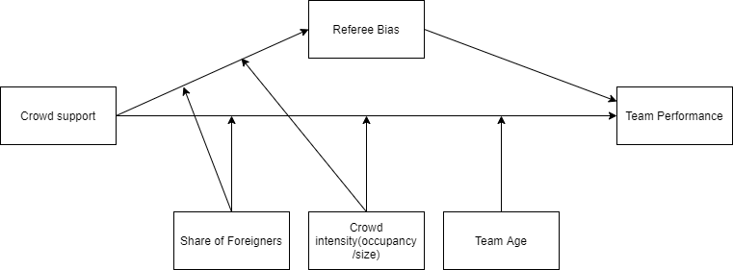

%3CmxGraphModel%3E%3Croot%3E%3CmxCell%20id%3D%220%22%2F%3E%3CmxCell%20id%3D%221%22%20parent%3D%220%22%2F%3E%3CmxCell%20id%3D%222%22%20value%3D%22Crowd%20support%22%20style%3D%22rounded%3D0%3BwhiteSpace%3Dwrap%3Bhtml%3D1%3B%22%20vertex%3D%221%22%20parent%3D%221%22%3E%3CmxGeometry%20x%3D%2220%22%20y%3D%22110%22%20width%3D%22120%22%20height%3D%2260%22%20as%3D%22geometry%22%2F%3E%3C%2FmxCell%3E%3CmxCell%20id%3D%223%22%20value%3D%22Referee%20Bias%22%20style%3D%22rounded%3D0%3BwhiteSpace%3Dwrap%3Bhtml%3D1%3B%22%20vertex%3D%221%22%20parent%3D%221%22%3E%3CmxGeometry%20x%3D%22340%22%20y%3D%2220%22%20width%3D%22120%22%20height%3D%2260%22%20as%3D%22geometry%22%2F%3E%3C%2FmxCell%3E%3CmxCell%20id%3D%224%22%20value%3D%22Team%20Performance%22%20style%3D%22rounded%3D0%3BwhiteSpace%3Dwrap%3Bhtml%3D1%3B%22%20vertex%3D%221%22%20parent%3D%221%22%3E%3CmxGeometry%20x%3D%22660%22%20y%3D%22110%22%20width%3D%22120%22%20height%3D%2260%22%20as%3D%22geometry%22%2F%3E%3C%2FmxCell%3E%3CmxCell%20id%3D%225%22%20value%3D%22Share%20of%20Foreigners%22%20style%3D%22rounded%3D0%3BwhiteSpace%3Dwrap%3Bhtml%3D1%3B%22%20vertex%3D%221%22%20parent%3D%221%22%3E%3CmxGeometry%20x%3D%22200%22%20y%3D%22240%22%20width%3D%22120%22%20height%3D%2260%22%20as%3D%22geometry%22%2F%3E%3C%2FmxCell%3E%3CmxCell%20id%3D%226%22%20value%3D%22Crowd%20intensity(occupancy%26lt%3Bbr%26gt%3B%2Fsize)%22%20style%3D%22rounded%3D0%3BwhiteSpace%3Dwrap%3Bhtml%3D1%3B%22%20vertex%3D%221%22%20parent%3D%221%22%3E%3CmxGeometry%20x%3D%22340%22%20y%3D%22240%22%20width%3D%22120%22%20height%3D%2260%22%20as%3D%22geometry%22%2F%3E%3C%2FmxCell%3E%3CmxCell%20id%3D%227%22%20value%3D%22Team%20Age%22%20style%3D%22rounded%3D0%3BwhiteSpace%3Dwrap%3Bhtml%3D1%3B%22%20vertex%3D%221%22%20parent%3D%221%22%3E%3CmxGeometry%20x%3D%22480%22%20y%3D%22240%22%20width%3D%22120%22%20height%3D%2260%22%20as%3D%22geometry%22%2F%3E%3C%2FmxCell%3E%3CmxCell%20id%3D%228%22%20value%3D%22%22%20style%3D%22endArrow%3Dclassic%3Bhtml%3D1%3BentryX%3D0%3BentryY%3D0.5%3BentryDx%3D0%3BentryDy%3D0%3B%22%20edge%3D%221%22%20target%3D%224%22%20parent%3D%221%22%3E%3CmxGeometry%20width%3D%2250%22%20height%3D%2250%22%20relative%3D%221%22%20as%3D%22geometry%22%3E%3CmxPoint%20x%3D%22140%22%20y%3D%22140%22%20as%3D%22sourcePoint%22%2F%3E%3CmxPoint%20x%3D%2270%22%20y%3D%22320%22%20as%3D%22targetPoint%22%2F%3E%3CArray%20as%3D%22points%22%3E%3CmxPoint%20x%3D%22140%22%20y%3D%22140%22%2F%3E%3C%2FArray%3E%3C%2FmxGeometry%3E%3C%2FmxCell%3E%3CmxCell%20id%3D%229%22%20value%3D%22%22%20style%3D%22endArrow%3Dclassic%3Bhtml%3D1%3BexitX%3D1%3BexitY%3D0.5%3BexitDx%3D0%3BexitDy%3D0%3BentryX%3D0%3BentryY%3D0.5%3BentryDx%3D0%3BentryDy%3D0%3B%22%20edge%3D%221%22%20source%3D%222%22%20target%3D%223%22%20parent%3D%221%22%3E%3CmxGeometry%20width%3D%2250%22%20height%3D%2250%22%20relative%3D%221%22%20as%3D%22geometry%22%3E%3CmxPoint%20x%3D%22150%22%20y%3D%22160%22%20as%3D%22sourcePoint%22%2F%3E%3CmxPoint%20x%3D%22330%22%20y%3D%2250%22%20as%3D%22targetPoint%22%2F%3E%3C%2FmxGeometry%3E%3C%2FmxCell%3E%3CmxCell%20id%3D%2210%22%20value%3D%22%22%20style%3D%22endArrow%3Dclassic%3Bhtml%3D1%3BexitX%3D0.5%3BexitY%3D0%3BexitDx%3D0%3BexitDy%3D0%3B%22%20edge%3D%221%22%20source%3D%225%22%20parent%3D%221%22%3E%3CmxGeometry%20width%3D%2250%22%20height%3D%2250%22%20relative%3D%221%22%20as%3D%22geometry%22%3E%3CmxPoint%20x%3D%2220%22%20y%3D%22370%22%20as%3D%22sourcePoint%22%2F%3E%3CmxPoint%20x%3D%22260%22%20y%3D%22140%22%20as%3D%22targetPoint%22%2F%3E%3C%2FmxGeometry%3E%3C%2FmxCell%3E%3CmxCell%20id%3D%2211%22%20value%3D%22%22%20style%3D%22endArrow%3Dclassic%3Bhtml%3D1%3BexitX%3D1%3BexitY%3D0.5%3BexitDx%3D0%3BexitDy%3D0%3BentryX%3D0%3BentryY%3D0.25%3BentryDx%3D0%3BentryDy%3D0%3B%22%20edge%3D%221%22%20source%3D%223%22%20target%3D%224%22%20parent%3D%221%22%3E%3CmxGeometry%20width%3D%2250%22%20height%3D%2250%22%20relative%3D%221%22%20as%3D%22geometry%22%3E%3CmxPoint%20x%3D%2220%22%20y%3D%22370%22%20as%3D%22sourcePoint%22%2F%3E%3CmxPoint%20x%3D%22650%22%20y%3D%22120%22%20as%3D%22targetPoint%22%2F%3E%3C%2FmxGeometry%3E%3C%2FmxCell%3E%3CmxCell%20id%3D%2212%22%20value%3D%22%22%20style%3D%22endArrow%3Dclassic%3Bhtml%3D1%3B%22%20edge%3D%221%22%20source%3D%226%22%20parent%3D%221%22%3E%3CmxGeometry%20width%3D%2250%22%20height%3D%2250%22%20relative%3D%221%22%20as%3D%22geometry%22%3E%3CmxPoint%20x%3D%22400%22%20y%3D%22230%22%20as%3D%22sourcePoint%22%2F%3E%3CmxPoint%20x%3D%22400%22%20y%3D%22140%22%20as%3D%22targetPoint%22%2F%3E%3C%2FmxGeometry%3E%3C%2FmxCell%3E%3CmxCell%20id%3D%2213%22%20value%3D%22%22%20style%3D%22endArrow%3Dclassic%3Bhtml%3D1%3BexitX%3D0.5%3BexitY%3D0%3BexitDx%3D0%3BexitDy%3D0%3B%22%20edge%3D%221%22%20source%3D%227%22%20parent%3D%221%22%3E%3CmxGeometry%20width%3D%2250%22%20height%3D%2250%22%20relative%3D%221%22%20as%3D%22geometry%22%3E%3CmxPoint%20x%3D%2220%22%20y%3D%22370%22%20as%3D%22sourcePoint%22%2F%3E%3CmxPoint%20x%3D%22540%22%20y%3D%22140%22%20as%3D%22targetPoint%22%2F%3E%3C%2FmxGeometry%3E%3C%2FmxCell%3E%3CmxCell%20id%3D%2214%22%20value%3D%22%22%20style%3D%22endArrow%3Dclassic%3Bhtml%3D1%3BexitX%3D0.5%3BexitY%3D0%3BexitDx%3D0%3BexitDy%3D0%3B%22%20edge%3D%221%22%20source%3D%225%22%20parent%3D%221%22%3E%3CmxGeometry%20width%3D%2250%22%20height%3D%2250%22%20relative%3D%221%22%20as%3D%22geometry%22%3E%3CmxPoint%20x%3D%2220%22%20y%3D%22370%22%20as%3D%22sourcePoint%22%2F%3E%3CmxPoint%20x%3D%22210%22%20y%3D%22110%22%20as%3D%22targetPoint%22%2F%3E%3C%2FmxGeometry%3E%3C%2FmxCell%3E%3CmxCell%20id%3D%2215%22%20value%3D%22%22%20style%3D%22endArrow%3Dclassic%3Bhtml%3D1%3B%22%20edge%3D%221%22%20parent%3D%221%22%3E%3CmxGeometry%20width%3D%2250%22%20height%3D%2250%22%20relative%3D%221%22%20as%3D%22geometry%22%3E%3CmxPoint%20x%3D%22400%22%20y%3D%22240%22%20as%3D%22sourcePoint%22%2F%3E%3CmxPoint%20x%3D%22270%22%20y%3D%2280%22%20as%3D%22targetPoint%22%2F%3E%3C%2FmxGeometry%3E%3C%2FmxCell%3E%3CmxCell%20id%3D%2216%22%20value%3D%22%22%20style%3D%22endArrow%3Dnone%3Bdashed%3D1%3Bhtml%3D1%3B%22%20edge%3D%221%22%20parent%3D%221%22%3E%3CmxGeometry%20width%3D%2250%22%20height%3D%2250%22%20relative%3D%221%22%20as%3D%22geometry%22%3E%3CmxPoint%20x%3D%22620%22%20y%3D%2250%22%20as%3D%22sourcePoint%22%2F%3E%3CmxPoint%20x%3D%22620%22%20y%3D%2250%22%20as%3D%22targetPoint%22%2F%3E%3C%2FmxGeometry%3E%3C%2FmxCell%3E%3C%2Froot%3E%3C%2FmxGraphModel%3E%3CmxGraphModel%3E%3Croot%3E%3CmxCell%20id%3D%220%22%2F%3E%3CmxCell%20id%3D%221%22%20parent%3D%220%22%2F%3E%3CmxCell%20id%3D%222%22%20value%3D%22Crowd%20support%22%20style%3D%22rounded%3D0%3BwhiteSpace%3Dwrap%3Bhtml%3D1%3B%22%20vertex%3D%221%22%20parent%3D%221%22%3E%3CmxGeometry%20x%3D%2220%22%20y%3D%22110%22%20width%3D%22120%22%20height%3D%2260%22%20as%3D%22geometry%22%2F%3E%3C%2FmxCell%3E%3CmxCell%20id%3D%223%22%20value%3D%22Referee%20Bias%22%20style%3D%22rounded%3D0%3BwhiteSpace%3Dwrap%3Bhtml%3D1%3B%22%20vertex%3D%221%22%20parent%3D%221%22%3E%3CmxGeometry%20x%3D%22340%22%20y%3D%2220%22%20width%3D%22120%22%20height%3D%2260%22%20as%3D%22geometry%22%2F%3E%3C%2FmxCell%3E%3CmxCell%20id%3D%224%22%20value%3D%22Team%20Performance%22%20style%3D%22rounded%3D0%3BwhiteSpace%3Dwrap%3Bhtml%3D1%3B%22%20vertex%3D%221%22%20parent%3D%221%22%3E%3CmxGeometry%20x%3D%22660%22%20y%3D%22110%22%20width%3D%22120%22%20height%3D%2260%22%20as%3D%22geometry%22%2F%3E%3C%2FmxCell%3E%3CmxCell%20id%3D%225%22%20value%3D%22Share%20of%20Foreigners%22%20style%3D%22rounded%3D0%3BwhiteSpace%3Dwrap%3Bhtml%3D1%3B%22%20vertex%3D%221%22%20parent%3D%221%22%3E%3CmxGeometry%20x%3D%22200%22%20y%3D%22240%22%20width%3D%22120%22%20height%3D%2260%22%20as%3D%22geometry%22%2F%3E%3C%2FmxCell%3E%3CmxCell%20id%3D%226%22%20value%3D%22Crowd%20intensity(occupancy%26lt%3Bbr%26gt%3B%2Fsize)%22%20style%3D%22rounded%3D0%3BwhiteSpace%3Dwrap%3Bhtml%3D1%3B%22%20vertex%3D%221%22%20parent%3D%221%22%3E%3CmxGeometry%20x%3D%22340%22%20y%3D%22240%22%20width%3D%22120%22%20height%3D%2260%22%20as%3D%22geometry%22%2F%3E%3C%2FmxCell%3E%3CmxCell%20id%3D%227%22%20value%3D%22Team%20Age%22%20style%3D%22rounded%3D0%3BwhiteSpace%3Dwrap%3Bhtml%3D1%3B%22%20vertex%3D%221%22%20parent%3D%221%22%3E%3CmxGeometry%20x%3D%22480%22%20y%3D%22240%22%20width%3D%22120%22%20height%3D%2260%22%20as%3D%22geometry%22%2F%3E%3C%2FmxCell%3E%3CmxCell%20id%3D%228%22%20value%3D%22%22%20style%3D%22endArrow%3Dclassic%3Bhtml%3D1%3BentryX%3D0%3BentryY%3D0.5%3BentryDx%3D0%3BentryDy%3D0%3B%22%20edge%3D%221%22%20target%3D%224%22%20parent%3D%221%22%3E%3CmxGeometry%20width%3D%2250%22%20height%3D%2250%22%20relative%3D%221%22%20as%3D%22geometry%22%3E%3CmxPoint%20x%3D%22140%22%20y%3D%22140%22%20as%3D%22sourcePoint%22%2F%3E%3CmxPoint%20x%3D%2270%22%20y%3D%22320%22%20as%3D%22targetPoint%22%2F%3E%3CArray%20as%3D%22points%22%3E%3CmxPoint%20x%3D%22140%22%20y%3D%22140%22%2F%3E%3C%2FArray%3E%3C%2FmxGeometry%3E%3C%2FmxCell%3E%3CmxCell%20id%3D%229%22%20value%3D%22%22%20style%3D%22endArrow%3Dclassic%3Bhtml%3D1%3BexitX%3D1%3BexitY%3D0.5%3BexitDx%3D0%3BexitDy%3D0%3BentryX%3D0%3BentryY%3D0.5%3BentryDx%3D0%3BentryDy%3D0%3B%22%20edge%3D%221%22%20source%3D%222%22%20target%3D%223%22%20parent%3D%221%22%3E%3CmxGeometry%20width%3D%2250%22%20height%3D%2250%22%20relative%3D%221%22%20as%3D%22geometry%22%3E%3CmxPoint%20x%3D%22150%22%20y%3D%22160%22%20as%3D%22sourcePoint%22%2F%3E%3CmxPoint%20x%3D%22330%22%20y%3D%2250%22%20as%3D%22targetPoint%22%2F%3E%3C%2FmxGeometry%3E%3C%2FmxCell%3E%3CmxCell%20id%3D%2210%22%20value%3D%22%22%20style%3D%22endArrow%3Dclassic%3Bhtml%3D1%3BexitX%3D0.5%3BexitY%3D0%3BexitDx%3D0%3BexitDy%3D0%3B%22%20edge%3D%221%22%20source%3D%225%22%20parent%3D%221%22%3E%3CmxGeometry%20width%3D%2250%22%20height%3D%2250%22%20relative%3D%221%22%20as%3D%22geometry%22%3E%3CmxPoint%20x%3D%2220%22%20y%3D%22370%22%20as%3D%22sourcePoint%22%2F%3E%3CmxPoint%20x%3D%22260%22%20y%3D%22140%22%20as%3D%22targetPoint%22%2F%3E%3C%2FmxGeometry%3E%3C%2FmxCell%3E%3CmxCell%20id%3D%2211%22%20value%3D%22%22%20style%3D%22endArrow%3Dclassic%3Bhtml%3D1%3BexitX%3D1%3BexitY%3D0.5%3BexitDx%3D0%3BexitDy%3D0%3BentryX%3D0%3BentryY%3D0.25%3BentryDx%3D0%3BentryDy%3D0%3B%22%20edge%3D%221%22%20source%3D%223%22%20target%3D%224%22%20parent%3D%221%22%3E%3CmxGeometry%20width%3D%2250%22%20height%3D%2250%22%20relative%3D%221%22%20as%3D%22geometry%22%3E%3CmxPoint%20x%3D%2220%22%20y%3D%22370%22%20as%3D%22sourcePoint%22%2F%3E%3CmxPoint%20x%3D%22650%22%20y%3D%22120%22%20as%3D%22targetPoint%22%2F%3E%3C%2FmxGeometry%3E%3C%2FmxCell%3E%3CmxCell%20id%3D%2212%22%20value%3D%22%22%20style%3D%22endArrow%3Dclassic%3Bhtml%3D1%3B%22%20edge%3D%221%22%20source%3D%226%22%20parent%3D%221%22%3E%3CmxGeometry%20width%3D%2250%22%20height%3D%2250%22%20relative%3D%221%22%20as%3D%22geometry%22%3E%3CmxPoint%20x%3D%22400%22%20y%3D%22230%22%20as%3D%22sourcePoint%22%2F%3E%3CmxPoint%20x%3D%22400%22%20y%3D%22140%22%20as%3D%22targetPoint%22%2F%3E%3C%2FmxGeometry%3E%3C%2FmxCell%3E%3CmxCell%20id%3D%2213%22%20value%3D%22%22%20style%3D%22endArrow%3Dclassic%3Bhtml%3D1%3BexitX%3D0.5%3BexitY%3D0%3BexitDx%3D0%3BexitDy%3D0%3B%22%20edge%3D%221%22%20source%3D%227%22%20parent%3D%221%22%3E%3CmxGeometry%20width%3D%2250%22%20height%3D%2250%22%20relative%3D%221%22%20as%3D%22geometry%22%3E%3CmxPoint%20x%3D%2220%22%20y%3D%22370%22%20as%3D%22sourcePoint%22%2F%3E%3CmxPoint%20x%3D%22540%22%20y%3D%22140%22%20as%3D%22targetPoint%22%2F%3E%3C%2FmxGeometry%3E%3C%2FmxCell%3E%3CmxCell%20id%3D%2214%22%20value%3D%22%22%20style%3D%22endArrow%3Dclassic%3Bhtml%3D1%3BexitX%3D0.5%3BexitY%3D0%3BexitDx%3D0%3BexitDy%3D0%3B%22%20edge%3D%221%22%20source%3D%225%22%20parent%3D%221%22%3E%3CmxGeometry%20width%3D%2250%22%20height%3D%2250%22%20relative%3D%221%22%20as%3D%22geometry%22%3E%3CmxPoint%20x%3D%2220%22%20y%3D%22370%22%20as%3D%22sourcePoint%22%2F%3E%3CmxPoint%20x%3D%22210%22%20y%3D%22110%22%20as%3D%22targetPoint%22%2F%3E%3C%2FmxGeometry%3E%3C%2FmxCell%3E%3CmxCell%20id%3D%2215%22%20value%3D%22%22%20style%3D%22endArrow%3Dclassic%3Bhtml%3D1%3B%22%20edge%3D%221%22%20parent%3D%221%22%3E%3CmxGeometry%20width%3D%2250%22%20height%3D%2250%22%20relative%3D%221%22%20as%3D%22geometry%22%3E%3CmxPoint%20x%3D%22400%22%20y%3D%22240%22%20as%3D%22sourcePoint%22%2F%3E%3CmxPoint%20x%3D%22270%22%20y%3D%2280%22%20as%3D%22targetPoint%22%2F%3E%3C%2FmxGeometry%3E%3C%2FmxCell%3E%3CmxCell%20id%3D%2216%22%20value%3D%22%22%20style%3D%22endArrow%3Dnone%3Bdashed%3D1%3Bhtml%3D1%3B%22%20edge%3D%221%22%20parent%3D%221%22%3E%3CmxGeometry%20width%3D%2250%22%20height%3D%2250%22%20relative%3D%221%22%20as%3D%22geometry%22%3E%3CmxPoint%20x%3D%22620%22%20y%3D%2250%22%20as%3D%22sourcePoint%22%2F%3E%3CmxPoint%20x%3D%22620%22%20y%3D%2250%22%20as%3D%22targetPoint%22%2F%3E%3C%2FmxGeometry%3E%3C%2FmxCell%3E%3C%2Froot%3E%3C%2FmxGraphModel%3E

## Data and Methodology

## 3.1 Data collection

The website: [http://www.football-data.co.uk](http://www.football-data.co.uk/data.php) provides weekly updated datasets for all important leagues around the world. The datasets include statistics on full-time and half-time results, shots, shots on targets, number of fouls, number of yellow and red cards and corners for each team on match level. Our sample includes all the matches played from season 2018/19 onwards. We chose 2018/19 as cutoff since the VAR got introduced around this time in most competitions.[1] Var has major implications especially in the realm of crowd supports influence on decision making by referees. The referee can be overruled by the video referee, often located outside of the stadium, and thus less influenced by crowd noise. We decided to analyze the 9 of the top 10 leagues in Europe for purposes of data availability and data convenience. The 9 leagues incorporated are: Dutch Eredivisie, German Bundesliga, Portuguese Primeira Liga, The Turkish Super Lig, Belgian Jupiler League, French Ligue 1, English Premier League, Spanish Primera Division. We added a dummy variable equal to 0 for the leagues where the VAR had not been introduced yet in a particular season, which was only the case for the 2018/19 Premier League and 2018/19 Primeira liga seasons. For data on our 3 moderators: team age, proportion of foreigners playing for the team and crowd occupancy, we consulted the website of transfermarkt.com.

We include two measures of team performance in our model; the difference between points obtained by the home and away team and the difference in goals scored by the home and away team. Points obtained by teams is the primary measure of match outcome in football. We also use goal difference because information on goal difference in a match can give insight into the magnitude of a win. A 2-1 win and a 5-0 win both result in the same points difference but represent completely different matches.

We also need to control for potential endogeneity resulting from other variables affecting team performance. Team performance depends heavily on the quality of the team (Lago-Peñas & Lago-Ballesteros, 2011). Thus a measure of team strength should be included in the model as control variable. The most comprehensive measurement of team strength we know is the SPI index used by FiveThirtyEight[2]. Their SPI index is constructed by computing an offensive rating and defensive rating. This rating is equal to the number of goals expected to score/concede by the team against an average opponent on neutral ground. The SPI then is the percentage of points that the team will take if the match against an average team on neutral ground is played. FiveThirtyEight’s public github repository provides weekly updated dataset with SPI data. Another variable influencing team performance is the importance of a match. Link & de Lorenzo (2018) discovered that players and make more faster runs and more fouls in matches that were influential on final ranking compared to matches which were not. Intuitively it makes sense that a team will attempt to peak for a match that is important and be less focused and motivated when the outcome of the match has no consequences. The SPI dataset also includes a measure of match importance for both the home and away team. The match importance is calculated through expected probabilities of each match outcome that would alter the ranking of the team in the competition.

Since our sample includes multiple leagues, we need to account for potential country specific differences that could confound the relationships within our model. Therefore we add a dummy variable for each league in our regression model to control for these league specific differences. Additionally, for our regression model for referee bias, a confounding variable could be the dominance in a match. Attacking teams dominant teams with more possession will make less fouls within a match (McCarick et al 2020; Goumas, 2014b). If home teams play more attacking football and therefore need to commit less fouls, the referee bias we found might simply be a result of the playing style and not from an actual bias in referee decision making. Therefore we include the difference in shots between home and away teams into our model.

## 3.2 Variable Operationalization

In table 2 we provide an overview of the main variables included in our analsyis with an explanation on how the variable is operationalized within our dataset. Our unit of analysis is a match between two football teams, with the team playing at home called “Home Team” and the team playing away “Away Team”. For many of our variables withinin our dataset we use the differences between home and away metrics within the match to reduce the number of variables used in our models. For the majority of these differences, we calculate the difference by subtracting away values from home values. For example, goal difference is calculated as # of goals scored by the home team minus # of goals scored by the away team. However, for referee decisions we decided to reverse the calculation to facillitate interpretation of outcomes. When calculated in this way, a positive difference in cards implies higher cards for away teams, which can be seen as a positive bias towards home teams.

**Table 2 Variable operationalization**

## 

## 3.3 Descriptive statistics

Table 3 provides the descriptive statistics for the variables mentioned in section 3.2.

The data set contains match data for 8137 matches played in 9 major leagues of Europe. We observe that home teams on average score .292 goals more and collect .365 more points han away teams. Furthermore, the table reveals that home teams on average receive .185 fewer yellow cards and .026 fewer red cards than away teams, while committing .107 fouls less on average. Appendix 1a contains the full summary statistics table.

**Table 3 Summary Statistics**



## 3.4 Home advantage pre and post covid-19

For the entire sample, there is a clear home advantage, with more points, and more goals for home teams over the past 3 years. However, solely based on the entire sample we cannot conclude whether home advantage has remained during covid-19. Therefore we split the dataset into two different datasets with one dataset containing matches only played before covid-19 and the other only containing matches played after covid-19. 2,996 of the matches have been played behind closed doors and 5,141 were played with spectators present. We proceed with statistical tests to examine whether home advantage has changed significantly following the covid-19 pandemic. Due to the continuous nature of our variables we used a Mann-Whitney U test, which handles our non-normal data better than traditional t-tests. For the percentage of home and away wins,which are coded as categorical variables, we performed a chi square test of comparison. Table 4 contains the mean pre and post covid-19 values for our variables of interest accompanied by p-values for the null hypothesis of equal distributions.

**Table 4 mean level differences pre and post covid**

*****Note*: Statistic is the Mann-Whitney Estimate, tests 0 hypothesis of equal distribution. Significance levels: *p* < .05* , *p* < .01 **, *p < .001 \*\*\**

The gap between home and away teams for both expected and actual goals has declined significantly following the disappearance of crowd support. Table 4 proves that with supporters, home teams scored .36 more goals than away teams per match, a number that fell to .17(*p* < .001) when crowd support was absent. For expected goals, we see a similar drop from .31 to .16(*p <* .001). Table 4 also shows the differences in referee punishments before and after covid. In matches without crowd support, the difference in yellow cards has been reduced by .3 (*p* < .001), the difference in red cards by.02(*p* = .010) and the difference in fouls has been reduced by .5 (*p* < .001) relative to away teams compared to matches with crowd support. These results imply that away teams have been punished less severely relative to the home team in matches without crowd support. These differences are depicted in graph 4, clearly highlighting the change in referee decisions during the pandemic.

**Figure 2 Comparison of Foul, Yellow card and Red card gap**

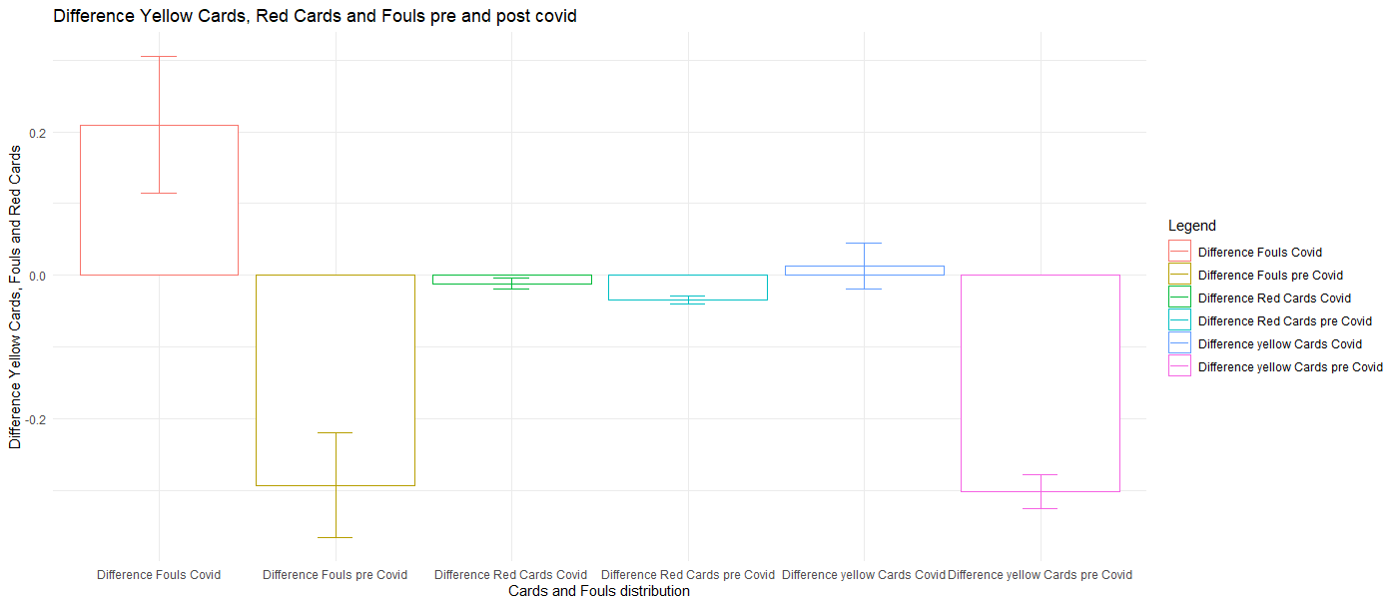

*Note:* for each pair of bars, the left bar represents the level during the covid pandemic, with the right bar representing the levels before the pandemic. From left to right, we compare Fouls, red cards and yellow cards. Error bars represent 95% confidence interval for mean value.

**Figure 3 The difference in Yellow Cards over time**

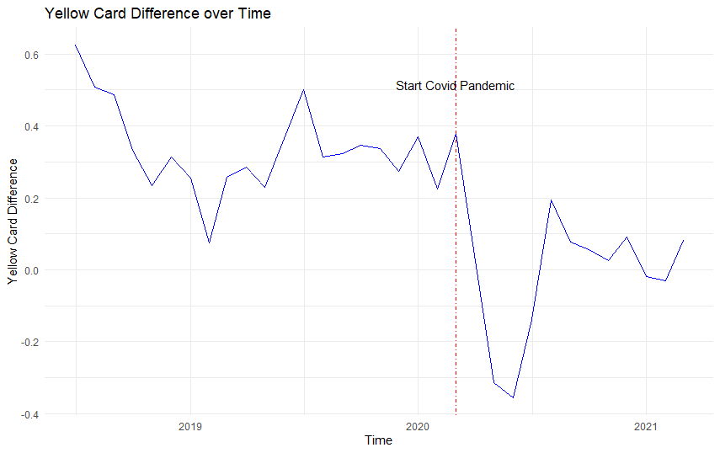

*Note*: the blue line indicates the average yellow card difference per month for each month with matches played in our sample, the vertical red dashed line indicates the start of the covid pandemic.

Figure 3 shows the trend in the differences in yellow cards between home and away teams. We observe a significant dip in the few months after the covid pandemic but interestingly towards the end of 2020 we see the difference decreasing again, to remain relatively stable in 2021. This suggests that the effect of missing supporters was the heaviest right after the restart, with referees adjusting to the new situation afterwards. Appendix 3a and 3b show similar but less extreme drops in red card difference and foul difference immediately after the start of the pandemic.

Our statistics on differences show that there has been a significant reduction in differences between home and away teams on various metrics. However, it does not show wheter these differences stern from reduced home team performance or increased away team performance,. Or in the case of referee decisions, whether the differences come from from reduced punishment for away teams or increased punishment for home teams. We delve deeper into home and away team data to uncover these patterns. Table 7 below presents the results for referee decisions. The results in the table are revealing in several ways. Firstly, It seems that rather than punishing home teams more severely, the gap in cards has mainly been reduced by a more lenient attitude towards away teams who receive significantly lower numbers of yellow and red cards since the start of the pandemic, while not making significantly more fouls. Secondly, somewhat contradictory to the first finding is that despite the significant increase in fouls made by the home team, the number of cards the home team received remained relatively stable. This could be interpreted as less severe punishment for fouls, or perhaps that home teams made more small fouls that were not heavy enough to be a bookable offense.

**Table 5 mean levels referee metrics pre and post covid**

*****Note:* Statistic is the Mann-Whitney Estimate, tests 0 hypothesis of equal distribution. Significance levels: *p* < .05* , *p* < .01 **, *p < .001 \*\*\**

To distinguish between differences in home and away performance. We provide the same table for different metrics of match outcome and team performance from both a home team and away team perspective. As shown in table 6 on the next page, the performance of home and away teams has changed significantly after the start of the covid-19 pandemic. The percentage of wins at home has declined 5 percent from 45 percent pre covid to 40 percent post covid (*p <*.001*)* whereas the percentage away wins have rose from 30 to 34 percent (*p <*.001*)*. The chi square proportion test we used to test for difference in proportions home and away wins gives a chi square value of 74.252 (*p <*.001) which suggests that home advantage indeed has significantly decreased following the exclusion of home supporters.

Also number of goals and points for home teams declined substantially. Away teams fare better in games behind closed doors compared to games with fans.With crowd support, away teams on average collected 1.14 points per game, scoring an average of 1.22 goals per game in the process. When crowd support is not present however, away teams have increased their points per game to 1.27(*p <*.001) also increasing the amount of goals scored on average by 0.07 to 1.29 goals per game(*p <*.001). There is clear evidence of a decrease in home advantage following the exclusion of home fans.

**Table 6 mean levels performance metrics pre and post covid**

*****Note: ^ = chi square statistic, others = Mann-Whitney estimate. ,* Significance levels: *p* < .05* , *p* < .01 **, *p < .001 \*\*\**

We also examine differences in expected goals. Metrics such as goals and points provide information on team performance but can be dependent on luck in finishing. Expected goals is a metric that calculates the quality of chances created by a team over the entire match and therefore is very suitable to evaluate team performance. The decrease in home advantage seem to come from both an increase in away team performance and a decrease in home team performance. With crowd support, home team’s actual goals slightly outperformed their expected goals, scoring 1.58 goals per match where 1.56 would be expected, whereas the away team’s actual goals where slightly below their expected goals value(1.22 to 1.25).

Both goal values have converged closer to their expected goals value after the lockdown, which has lead to a significant reduction in home advantage. Also, the decrease in expected goals for home teams is bigger, with an expected goals drop of over .1(*p* <.001) goals per match, compared to a .04 increase in expected goals for away teams(*p* = .044). This hints that decreased home advantage in a situation of no crowd support is to a greater extent caused by a drop in home team performance than to an improved away performance.The differences in goals and expected goals are displayed in figure 4.

**Figure 4 comparison of goal and expected goals gap**

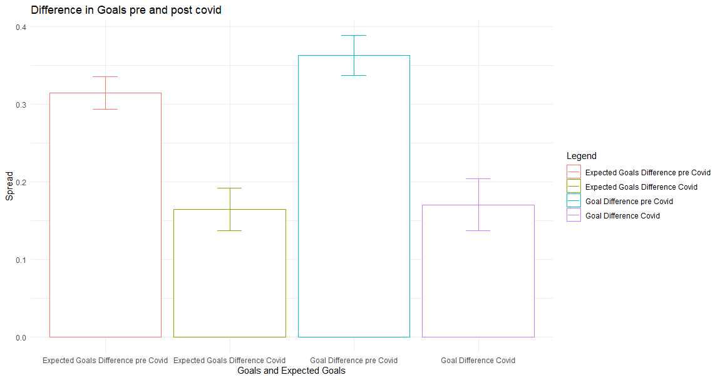

*Note:* for each pair of bars, the left bar represents the level before covid and the right bar the levels after covid. From left to right we compare Expected goals and Goals. Error bars represent 95% confidence interval for mean value.

On average, we observe a significant decline in the expected goals difference and goal difference in games without crowd support. In the next graph we examine the development of expected goals difference over time. From figure 5 we observe a sharp drop immediately after the start of the pandemic, however, contrary to referee decisions, for expected goals we do not see a movement back towards pre-covid levels as expected goals difference remain quite low. For points and goal difference hower, as shown in appendix 3c and 3d we see a sizeable increase after the initial drop.

**Figure 5 Expected goals difference**

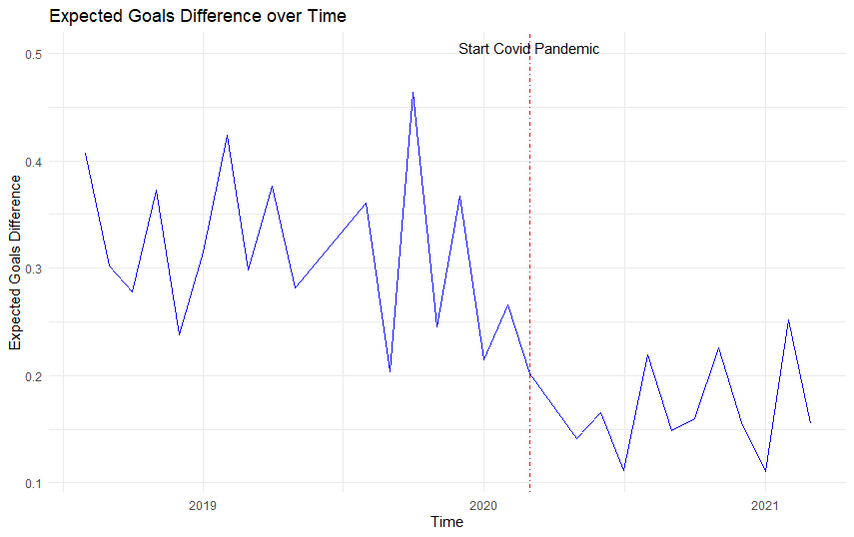

*Note:* the blue line indicates the mean difference in expected goals per month. The red dashed line indicates the start of the covid pandemic

## 3.5 Model

Our model free evidence indicates a significant reduction in home advantage in matches played without crowd support. However, based on these numbers we cannot make conclusions about causality mechanisms behind this reduction. In the next chapter we examine whether the absence of crowd support caused the drop in team performance relative to away team performance. In our model we scrutinize the possible mediating role of referee decision making in this process. Moreover, we check for the effects of multiple potential moderating variables: occupancy, crowd size, team age and the ratio of foreigners playing for a team. Finally, we add the control variables for team strength, match importance and Var availability. Our first equation involves the path between our independent variable crowd support and our mediating variable, referee bias.We measure crowd support as a dummy variable named covid that takes a value of 1 when a match was played after the start of the pandemic and thus without crowd support. Referee bias will enter the model as a latent construct measured from foul and yellow card decisions by the referee.

This leads to the following regression equation.

**Equation 1:** Referee Bias: *β0 + β1Covid + β2OccupancyRate + β3ForeignersShareDifference + β4Crowdsize + β5Covid*OccupancyRate + β6Covid * ForeignersShareDifference + β7Covid * Crowdsize + β8RatingDifference + β9ImportanceDifference + β10VAR +β11ShotsDifference + β12league + ɛ*

The second equation within our model is the path between our independent variable crowd support and our dependent variable team performance. We use 2 different measures of team performance, goal difference and points differrence to increase the robustness of our results.

**Equation 2:** Team Performance *= β0 + β1Covid+ β2OccupancyRate + β3ForeignersShareDifference + β4Crowdsize + β5AgeDifference + β6 Covid*OccupancyRate + β7 Covid * ForeignersShareDifference + β8 Covid * Crowdsize + β9 Covid * AgeDifference + β10RatingDifference + β11ImportanceDifference + β12VAR +β13league + β14Referee bias + ɛ*

Since we want to assess multiple relationships and also include a latent construct within our model we deem a SEM model most suitable for our analysis. Hair, Black, Babin, Anderson and Tatham (2014) state the main advantage of SEM models vis-à-vis other powerful techniques such as multiple regression and factor analysis is that SEM allows for the examination of multiple relationships together simultaneously.Furthermore, SEM allows both latent and observed constructs in the model. We use the lavaan package in R to conduct our analysis.

## Analysis and Findings

In this chapter we deploy our previously defined model on our dataset in order to examine the causal relationships within our conceptual framework. We estimate a linear regression within our Structural Equation model, and therefore we start by checking the assumptions for linear models to see whether our data is suitable for model deployment or that some data transformations are required. We use the method proposed by Pena & Slate (2006) who introduce a global test for the major assumptions for linear models.

## 4.1 Assumptions

**Normality:** The Anderson-Darling tests show that our variables are not normally distributed, the results of these tests are shown in appendix 2a. To assess multivariate normality we use the globalized gvlma test, which tests multiple assumptions of linear regression in combination to eachother. Pena & Slate (2006) mention, assumptions are often interrelated with eachother, which makes the combined test powerful as it takes these interactions into account. The test result in appendix 4a, 4b and 4c show that similar to univariate normality, the assumption of multivariate normality is violated. However, the central limit theorem states that for large samples with sample size over 30, these deviations from normality are not problematic (Brosamler, 1985). With our sample size of over 8,000, we can safely ignore the normality assumption and proceed further.

**Multicollinearity**: When interpreting the correlation table in appendix 7 we see a few high correlations. Notably between our control variable Rating difference and our dependent outcomes, as well as correlation between Rating Difference and Importance Difference. Furthermore, there exists a correlation of 0.75 between occupancy rate and average attendance, which makes sense since these variables are closely related. We calculate the variance inflation factors for our model variables, the output of which is shown in appendix 8a and 8b. A frequently used benchmark for VIF values is 10 (Vittinghof, Glidden, Shiboski and McCulloch , 2011). James, Witten, Hastie and Tibshirani(2013) on the other hand pose a value of VIF over 5 to be problematic. The highest VIF factor within our model is 3.09 , therefore we can safely assume that multicollinearity is not a problem within our model.

**Homoscedasticity:** The assumption of homoscedasticity is important for the ability to interpret standard errors of our model. The gvlma test also tests for homoscedasticity within our sample, non-constant error variance test to test for homoscedasticity. As we observe from appendix 4a and 4b, for both our equations, the test statistic is insignificant( *p* = .95 and *p* = .94) and as such we conclude that the assumption of homoscedasticity is met in our model.

We mean centered all our moderating variables to ease interpretation of the moderating effect on the relationship between crowd support and team performance, a step deemed necessary in moderation analysis. (Iacobucci, Schneider, Popovich & Bakamitsos, 2017). Additionally, since some of the moderating variables within our model are measured on different scales, we standardize them as well.

## 4.2 Results overview

Table 7 shows the results of our moderated mediation analysis

**Table 7 Model estimates**



The main goal of our study was to examine whether crowd support has a significant effect on team performance. In our first hypothesis we formulated the expectation that crowd support significantly impacts team performance. In our model we find evidence to support this hypothesis , the coefficient of -.538 (*p* < .001) implies that the disappearance of crowd support decreased the points gap between home and away teams by .538 points per match, when controlling for various factors such as match importance and team rating.

In hypothesis 1b we defined the moderating effect of crowd size, with larger crowds magnifying the effect of crowd support on team performance. Supporting the findings of Fischer & Haucap (2020) but contrary to the results of among other (Agnew & Carron, 1994) we find no evidence for the moderating effect of crowd size on the relationship between crowd support and team performance.(*β* = .041, *p = .568).* Therefore we reject the hypothesis.Apparently a larger crowd size does not result in a larger boost from crowd support in team performance. The presence of a home crowd increases home team performance but whether this is a crowd of 500 or 50,000 might be not important for football players. This could explain the fact that home advantage still exists at amateur levels, with very small crowd sizes generally.

Contrary to crowd size, crowd occupancy do seems to matter for crowd supports effect on team performance. We find that for high levels of crowd occupancy, the loss of performance following the absence of crowds is as high as .73 For low levels of occupancy however, this effect is only .34. Teams with higher occupancy rates got hit harder by the fact that crowd support disappeared following the covid-19 outbreak. This also implies that in matches where crowd support is present, they have a bigger home advantage all else equal, and thus perform better compared to teams with low occupancy rates.

Contrary to our expectations we conclude that player age is not a significant moderator of the relationship between crowd support and team performance (*β* = -.077, *p = .162).*  In other words, there is no significant difference in the influence of crowd support on team performance for younger or older teams. However, since previous finding such as those by van der Ven(2016) were relatively small, the insignificance of this moderator is not entirely unexpected. Moreover, the average age of the teams were quite close to eachother, with the difference between 25th and 75th percentile being 1.9 years. Perhaps due to the nature of the data we used for team age, there was low variation in team performance, since a majority of the teams would have both old and young players.

We also do not find evidence to support our hypothesis that the share of foreigners moderates the relationship between crowd support and team performance (*β* = -.008, *p = .882).* Apparently, the share of foreigners does not affect stadium atmosphere significantly enough to warrant larger effects on referee bias. Should crowd atmosphere really be affected by the share of foreigners, the total change in stadium atmosphere is apparently not large enough to significantly influence team performance.

Our 2nd group of hypotheses concerned the mediating effect of referee bias on the relationship between crowd support and team performance. The coefficient for the indirect effect of crowd support on team performance with a value of -.023(*p* = .032) signals that referee bias indeed mediates the relationship between crowd support and team performance. In the post-pandemic situation with no crowd support, the actual referee bias decreased and therefore reduced the point gap between home and away teams. However, crowd occupancy and crowd size do not seem to matter for referee bias. Apparently, the sole fact that a home crowd is present leads to an increased referee bias in favour of home teams, but the number of home fans or the degree to which the stadium capacity is filled do not influence the bias of referees.

The control variables importance difference and rating difference have face-valid effects. All else equal, a higher rating(*β* = .053, *p <* .001) for the home team and a higher match importance for the home team(*β* = .002, *p <* .007) increase the points difference between home and away teams. This make sense, teams that are better will collect more points on average, and a team for whom the match is more important will be more motivated to play well and win the match. The league in which the match was played turns out to be not a significant predictor of points difference. This implies that the effects of crowd support on team performance are consistent across competitions.

**Table 8 Fit indices**



Table 8 provides an overview of the fit indices for our moderated mediation model. Our chi square statistic of 206.452 (*p* <.001). suggests a discrepancy between the actual and predicted observations.. However, Kyriazos (2018) mentions the sensitivity of the chi square statisticin relation to sample size. Since our sample of 8,054 is quite large we decided to ignore the chi square statistic measure of fit. To benchmark the goodness of fit of our model we use the standard that Dion(2008) provides in his paper on preferred values for the major fit measures of SEM. He proposes that the TLI measure should approach 1 preferably, our TLI has a value of .852 which is not great but not terrible either. Secondly, the CFI should have a minimum value of .90 for a model to be considered a “good fit”, Our CFI measure has a value of .931, which is above the desired cut-off value, we conclude that for this second metric our model seems to be acceptable. Thirdly, RMSEA is a measure of the difference in the sample data with what would be expected in the situation of a correct model. Thus for RMSEA the lower value the better, with .05 the generally accepted maximum value. Our value of .033 falls well within the acceptable range. The final measure we use is SRMR, which is the standardized difference between predicted and observed correlations (Taasoobshirazi & Wang, 2016). Similar to RMSEA, the cut-off value is .05 , with a value of .013 our model appears as good fit for the data. Overall our model seems to fit reasonably well, passing 3 out of 4 fit statistic cut-offs.

## 4.3 Robustness check

To ensure the robustness of our results, we deployed our model on a second measure of team performance. Points difference between home and away teams is the primary outcome metric of a football match, We also are interested in goal difference because not all wins are made the same. A narrow 1 goal margin win and a thumping 4 goal victory both have the same points result but very different match processes. Perhaps while home and away wins are evenly divided, every away win could be a scrappy 1-0 victory whereas all home wins are convincing 3-0 victories. In this case there is still a home advantage. Table 9 shows the results of the same model now regressed with Goal difference as dependent variable. Some coefficients slightly change in estimation but all the signs and signficance levels remain similar, such that our findings not only hold for point differences but also for goal differences. Strengthening the validity of our model findings.

**Table 9 Goal difference**



Table 10 below depicts the fit measures for our 2nd model. Similar to our first model we decided to ignore the significant chi square statistic as a consequence of our large sample size. For the other 4 fit measures, our model fits well to the data according to 3 out of 4. Therefore we deem our model to fit the data sufficiently.

**Table 10 Fit measure**



## 4.4 Moderating effect occupancy

Having ensured the robustness of our results, we scrutinize the effect of our only significant moderator crowd occupancy on the relationship between crowd support and team performance. We use the simple slope analysis, introduced by O’Connor (1998) to compare the differences between high and low levels of crowd occupancy. The standard levels used in the literature for high and low levels of a variable are one stadard deviation below and above the mean (O’Connor, 1998). Table 11 shows the differences in total effect of crowd support on team performance for high, low and medium levels of crowd support.

**Table 11 High versus Low Occupancy rates**



For both our measures of team performance, he effect of crowd support on team performance is significant for all levels of crowd occupancy. However the magnitude of the effect is vastly different. For low levels of crowd occupancy, the absence of crowd support decreases the points gap between teams with around .34. For high levels of crowd occupancy, this effect is more than twice as large with a decrease of around .74. Thus, teams with high occupancy rates pre covid suffered more from the absence of crowd support than teams with low occupancy rates. Conversely, teams with higher occupancy rates have a bigger home advantage when crowd support is actually present. In practice, this could mean that over the course of a season of 38 games, a team with a high occupancy rate compared to a team with a lower occupancy rate could collect around 4(19 home games * (.74-.34/2)) points more in home games purely because of the higher occupancy rate . With differences between teams close to eachother in the league table often being very marginal, these 4 points could be the difference between qualifying for the champions league rather than the europa league or between relegation and staying up, each of the outcomes associated with huge financial consequences. The champions league guarantees clubs an income of 15.25 million for participation alone with the option of millions in bonuses for winning matches and reaching further into the tournament. The Europa league on the other hand offers a mere 2.92 million starting fee and considerably lower bonuses.[3] Relegation has similar consequences, with Sky sports estimating the estimated loss in tv revenues for premier league clubs relegating to the championship to be at least 50 million.[4] A huge number that does not even account for potential losses in matchday revenue and commercial deals.

For Goals, we see that for low levels of crowd occupancy the gap between home and away goals is reduced by roughly .2 goals per game. For teams with high level of crowd occupancy this number changes however to .51. Again we see that teams with high occupany rates have been more heavily affected by the exclusion of home supporters.

In the next chapter we summarize our main findings and provide a schematic overview of the answers to our hypothesis. Subsequently we use our results to generate managerial recommendations for managers working at football clubs. Finally we provide the limitations of this study plus some possible areas for future research.

## Conclusion and Discussion

## 5.1 Conclusions

We document the effect of crowd support on team performance. We used the extraordinary opportunity of the covid-pandemic to systematically scrutinize a large number of matches played without fans in order to directly assess the impact of crowd support on team performance. We first investigated several metrics of referee decisions and team performance to uncover whether they were significantly different in matches with crowd support compared to matches without crowd support. We found that home advantage has decreased significantly but still exists without crowd support. Both home and away team performance has been affected following the absence of crowd support. Home teams score less, create less chances and take less points per game. Away teams, seem to have increased their effectivity, scoring significantly more goals and having a significantly higher epxected goals tally without having more shots or more shots on target.

Referees give less cards to away teams in matches without supporters while cautioning home teams similarly in matches with and without crowd support. The number of fouls for away teams remained stable in matches with and without crowd support while the number of fouls for home teams increased following the exclusion of away supporters.

Subsequently we proceeded to assess causality links between crowd support, referee decisions and team performance while including several marketing related moderating variables. Given the complexity of our model we used a structural equation modelling approach to effectively model the relationships between our numerous observable variables and the latent construct referee bias.

Table 12 provides a summary of our hypotheses generated in chapter 2 and the evidence we find for the hypotheses in our analysis.

**Table 12 results summary**



To summarize our findings, we find that crowd support significantly affects team performance, with the points gap reduced by .538 between home and away teams whereas the goals gap reduced by .356 following the exclusion of supporters. We further propose that crowd occupancy but not absolute crowd size affects the degree to which crowd support influences team performance. With higher occupancy rates increasing the points gap to .74 and goal gap to .51 This in comparison to lower occupancy rates which lowers the points gap and goal gap to .34 and .2 respectively. Furthermore, we find that crowd support not only directly influences team performance but also affects team performance indirectly through referee decisions. We do not find evidence that crowd size and crowd occupancy influence the relationship between crowd support and referee decisions. Furthermore, we do not find evidence to support the claims that the share of foreigners and the average age of teams influences the effect of crowd support on team performance, nor the effect of crowd support on referee decisions.

## 5.2 Managerial recommendations

The results of our study illustrate the significant effect of crowd support on referee decisions and team performance. Future researchers can take the notion of the influence of crows support on team performance in future research. Having directly estimated the relationship between crowd support and team performance by using the current circumstances in world-football, we add to similar studies performed to strengthen the call that crowd support indeed affects team performance. Additionally, researchers can use our concept of referee bias measured as a latent construct as a basis for further research on referee decision making. Marketing managers can use our insights to incorporate performance effects of their decisions into their decision making process. Our research shows that not crowd size but crowd occupancy matters for home advantage. The most important task for a marketing manager is to deploy the right marketing strategies to fill the stadium as much as possible Marketing managers who can effectively bring fans to the stadium can positively impact team performance, resulting in a few points extra per season. These few points could have a significant difference however on final outcome. In the league tables of 2018/19, for all of the leagues in our sample, four extra points would have helped at least one and often more of the relegated teams to stay up in the first division. Similarly, for all of the leagues apart from the Dutch, Belgian and Portuguese ones the teams without european spots or with europa league spots would have secured champions league football instead. As we mentioned before, reaching the champions league or staying up can have tremendous financial consequences.

Furthermore, a lot of clubs spend millions on the development of larger stadiums to increase attendances and consequently ticket revenues. Given the impact of occupancy rates, rather than trying to increase revenues by moving to bigger stadiums, perhaps a more viable strategy would be to remain in the same stadium to increase or ensure high occupancy rates. The remaining fans can be catered through attractive online engagement strategies and match coverage on tv. Future developments such as streaming services for broadcasting football matches could provides opportunities for marketing managers to increase customer revenue while optimizing stadium occupancy rates.

Another interesting finding is the lack of influence of foreign players on crowd atmosphere. As a consequence global marketing strategies to increase the global presence and increase associated revenue streams through for example social media engagement can then be used to generate more revenue. As such, using foreign players from exotic countries to increase fan engagement could be a viable option for football clubs. Examples nowadays include Ajax increasing their presence in Brazil through the purchase of local talents David Neres and Anthony. The welcome song that Ajax’ posted was well received and gained global attention, increasing the engagement with fans around the world. Since our results show that the share of foreigners does not significantly affect crowd supports influence on team performance, football clubs can buy these foreign players without having to worry about eventual negative side effects on crowd atmosphere and team performance.

## 5.3 Limitations and areas for future research

In the context of the widely used expression “no research is perfect research”, our study imposes several limitations, and subsequently, areas for future research.

Firstly a few of our moderators were limited in data availability. For our occupancy rates and average attendances, we used season average attendance data to compile these statistics while these statistics obviously differ per match. Some matches attract high attendance where other matches attract lower attenances over the course of a season. Secondly, our metric for the share of foreigners is calculated as the total playing time over the course of the season for foreign players divided by the total playing time over the course of the season for local players. This metric can be different per match as well. In similar fashion, average age is calculated as the average age of all players used over the course of the season instead of the average age of all players used within a particular match. We decided to use these seasonwide measures due to the availability of the data and time concerns. Per match data would have been very cumbersome to accumulate. Interesting extensions to improve the reliability of the effects of the previously mentioned variables could be web scrapers scraping match specific data for more precise data on these variables, to then conduct a similar study to this one.

A second area for future research could be a factor analysis to measure team performance. We used 2 seperate measures of team performance with goal difference and points difference. However, there are multiple other measures of team performance, both on outcome level such as we investigated and on deeper lying performance metrics such as shots, possession and expected goals. An interesting path for future research could be to investigate whether a latent construct of team performance can be constructed from all these different measures of team performance.

Thirdly, a possible extension of this study could be to delve deeper in referee characteristics that influence referee bias. Since it is established that crowd support influences referee behavior, kowing which type of referees are influenced disproportionally by crowd noise could provide useful in preparing referees for the influence of the crowd, as well as selecting the right candidates as potential referees. Fourthly, in our study we established the importance of occupancy rates on team performance and subsequently briefly touched upon how marketing managers play a role in attendance rates. Future studies could include a depeening on the factors that drive fan behaviour and stadium attendance. Deeper knowledge on what types of fans come to stadiums can improve customer targeting and improve the marketing efforts for football clubs both for attracting customers to the stadium as well as increased fan engagement and consumption through different channels.

Finally, in our study we use share of foreigners as the degree to which fans identify with their teams and subsequently the intensity with which they support their following the globalisation of football in recent years. However, a second way through which this increased globalisation of football clubs could influence atmosphere within the stadium is through the composition of the crowd itself. “Football tourism” is a well known term by know which signifies the influx of global supporters at renown european clubs at home matches (Graakjær & Grøn, 2020). These supporters their main goal is the experience of visiting a match and not necessarily rooting for the home team to win. An interesting future area for research could be to examine the impact of football tourism on crowd atmosphere and team performance.

## 

## 5.4 Final overview

In this study we examined the effect of crowd support on team performance and referee behaviour. We used the unique opportunity provided by the covid-19 pandemic to directly assess the impact of crowd support. We found that crowd support significantly influences both home team and away team performance and that part of this effect is mediated by the increased referee bias in favour of the home team as a consequence of crowd support in favour of the home team.

# 6. Bibliography

1. Adcroft, A., Teckman, J., & Madichie, N. (2009). Management implications of foreign players in the English Premiership League football. *Management Decision*.
2. Agnew, G. A., & Carron, A. V. (1994). Crowd effects and the home advantage. International Journal of Sport Psychology
3. Allen, M. S., & Jones, M. V. (2014). The home advantage over the first 20 seasons of the English Premier League: Effects of shirt colour, team ability and time trends. *International Journal of Sport and Exercise Psychology*, *12*(1), 10-18.
4. Boyko, R. H., Boyko, A. R., & Boyko, M. G. (2007). Referee bias contributes to home advantage in English Premiership football. Journal of sports sciences, 25(11), 1185-1194.
5. Brechot, M., & Flepp, R. (2020). Dealing with randomness in match outcomes: how to rethink performance evaluation in european club football using expected goals. Journal of Sports Economics
6. Brosamler, G. A. (1988, November). An almost everywhere central limit theorem. In *Mathematical Proceedings of the Cambridge Philosophical Society* (Vol. 104, No. 3, pp. 561-574). Cambridge University Press.
7. Carmichael, F., & Thomas, D. (2005). Home-field effect and team performance: evidence from English premiership football. Journal of sports economics, 6(3), 264-281.
8. Cheung, G. W., & Lau, R. S. (2008). Testing mediation and suppression effects of latent variables: Bootstrapping with structural equation models. *Organizational research methods*, *11*(2), 296-325.
9. Clarke, S. R., & Norman, J. M. (1995). Home ground advantage of individual clubs in English soccer. Journal of the Royal Statistical Society: Series D (The Statistician), 44(4), 509-521.
10. Csikszentmihalyi, M. (1990). Flow: The psychology of optimal experience. New York, NY: Harper & Row.
11. Decroos, T., Bransen, L., Van Haaren, J., & Davis, J. (2019, July). Actions speak louder than goals: Valuing player actions in soccer. In *Proceedings of the 25th ACM SIGKDD International Conference on Knowledge Discovery & Data Mining* (pp. 1851-1861).
12. Dion, P. A. (2008). Interpreting structural equation modeling results: A reply to Martin and Cullen. *Journal of business ethics*, *83*(3), 365-368.
13. Endrich, M., & Gesche, T. (2020). Home-bias in referee decisions: Evidence from “Ghost Matches” during the Covid19-Pandemic. Economics Letters, 197, 109621.
14. Fédération Internationale de Football Association. (2007). FIFA Big Count 2006: 270 million people active in football. Zurich: Fédération Internationale de Football Association.
15. Fédération Internationale de Football Association.(2019), FIFA activity report 2018. Retrieved from https://www.fifa.com/who-we-are/official-documents/
16. Fischer, K., & Haucap, J. (2020). Does crowd support drive the home advantage in professional soccer? Evidence from German ghost games during the COVID-19 pandemic.
17. Galariotis, E., Germain, C., & Zopounidis, C. (2018). A combined methodology for the concurrent evaluation of the business, financial and sports performance of football clubs: the case of France. Annals of Operations Research, 266(1), 589-612.
18. Garicano, L., Palacios-Huerta, I., & Prendergast, C. (2005). Favoritism under social pressure. Review of Economics and Statistics, 87(2), 208-216.
19. Goddard, J. (2006). Who wins the football?. Significance, 3(1), 16-19.
20. Goumas, C. (2013). Home Advantage and Crowd Size in Soccer: A Worldwide Study. *Journal of Sport Behavior*, *36*(4).
21. Goumas, C. (2014). Home advantage in Australian soccer. *Journal of Science and Medicine in Sport*, *17*(1), 119-123.
22. Goumas, C. (2014b). Home advantage and referee bias in European football. *European journal of sport science*, *14*(sup1), S243-S249.
23. Graakjær, N. J., & Grøn, R. (2020). Football tourism and the sounds of televised matches. In *The Routledge Companion to Media and Tourism* (pp. 83-91). Routledge.
24. Gutierrez, D. (2019). *Impact of Special Events and Fan-Player Bonding on Identified Fan Consumption-A Study of Professional Soccer in the United States* (Doctoral dissertation, Creighton University)
25. He, M., Cachucho, R., & Knobbe, A. J. (2015, September). Football Player's Performance and Market Value. In Mlsa@ pkdd/ecml (pp. 87-95).
26. Hoechle, D. (2007). Robust standard errors for panel regressions with cross-sectional dependence. *The stata journal*, *7*(3), 281-312.
27. Iacobucci, D., Schneider, M. J., Popovich, D. L., & Bakamitsos, G. A. (2017). Mean centering, multicollinearity, and moderators in multiple regression: The reconciliation redux. *Behavior research methods*, *49*(1), 403-404.
28. Inan, T. (2020). The Effect of Crowd Support on Home-Field Advantage: Evidence from European Football. Annals of Applied Sport Science,
29. James, G., Witten, D., Hastie, T., & Tibshirani, R. (2013). *An introduction to statistical learning* (Vol. 112, p. 18). New York: springer.
30. Kyriazos, T. A. (2018). Applied psychometrics: sample size and sample power considerations in factor analysis (EFA, CFA) and SEM in general. *Psychology*, *9*(08), 2207.
31. Lago-Peñas, C., & Lago-Ballesteros, J. (2011). Game location and team quality effects on performance profiles in professional soccer. *Journal of sports science & medicine*, *10*(3), 465.
32. Lee, H., Gipson, C., & Barnhill, C. (2017). Experience of spectator flow and perceived stadium atmosphere: Moderating role of team identification.*Sport Marketing Quarterly, 26*(2), 87-98
33. Magen, Z. (1980). Encounter group effects on soccer team performance. *Small Group Behavior*, *11*(3), 339-344.
34. McSharry, P. E. (2007). Altitude and athletic performance: statistical analysis using football results. Bmj, 335(7633), 1278-1281.
35. Müller, O., Simons, A., & Weinmann, M. (2017). Beyond crowd judgments: Data-driven estimation of market value in association football. European Journal of Operational Research, 263(2), 611-624.
36. Neave N, Wolfson S. Testosterone, territoriality, and the 'home advantage'. Physiol Behav 2003; 78: 269-75.
37. Neave N, Wolfson S. The home advantage: psychological and physiological factors in soccer. In: Lavalle D, Thatcher J, Jones MV, Eds. Coping and Emotion in Sport. New York, Nova Science Publishers 2004; 127-44.
38. Nevill, A. M., Newell, S. M., & Gale, S. (1996). Factors associated with home advantage in English and Scottish soccer matches. *Journal of sports sciences*, *14*(2), 181-186.
39. Nevill, A. M., & Holder, R. L. (1999). Home advantage in sport. Sports Medicine, 28(4), 221-236.
40. Nevill, A., Balmer, N., & Williams, M. (1999). Crowd influence on decisions in association football. The Lancet, 353(9162), 1416.
41. Nevill, A. M., Balmer, N. J., & Williams, A. M. (2002). The influence of crowd noise and experience upon refereeing decisions in football. Psychology of Sport and Exercise, 3(4), 261-272.
42. Peeters, T., & van Ours, J. C. (2021). Seasonal Home Advantage in English Professional Football; 1974–2018. *De Economist*, *169*(1), 107-126.
43. Pena, E. A., & Slate, E. H. (2006). Global validation of linear model assumptions. *Journal of the American Statistical Association*, *101*(473), 341-354.
44. Pinnuck, M., & Potter, B. (2006). Impact of on‐field football success on the off‐field financial performance of AFL football clubs. Accounting & Finance, 46(3), 499-517.
45. Pollard, R. (1986). Home advantage in soccer: A retrospective analysis. Journal of sports sciences, 4(3), 237-248.
46. Pollard, R. (2008). Home advantage in football: A current review of an unsolved puzzle. The open sports sciences journal, 1(1)
47. Pollard, R., & Pollard, G. (2005). Long-term trends in home advantage in professional team sports in North America and England (1876–2003). Journal of sports sciences, 23(4), 337-350.
48. Pollard, Richard,(2006), Home Advantage in Soccer: Variations in its Magnitude and a Literature Review of the Inter-related Factors Associated with its Existence , Journal of Sport Behavior, Vol. 29, Iss. 2, 169-189.
49. Ponzo, M., & Scoppa, V. (2018). Does the home advantage depend on crowd support? Evidence from same-stadium derbies. Journal of Sports Economics, 19(4), 562-582.
50. Poulter, D. R. (2009). Home advantage and player nationality in international club football. *Journal of sports sciences*, *27*(8), 797-805.
51. Rodríguez, P., Humphreys, B. R., & Simmons, R. (Eds.). (2017). The Economics of Sports Betting. Edward Elgar Publishing.
52. Salminen, S. (1993). The effect of the audience on the home advantage. *Perceptual and motor skills*, *76*(3_suppl), 1123-1128.
53. Samagaio, A., Couto, E., & Caiado, J. (2009). Sporting, financial and stock market performance in English football: an empirical analysis of structural relationships. Journal Department of Management, ISEG/School of Economics and Management, Techincal University of Lisbon, Portugal.
54. Schwartz, B., & Barsky, S. F. (1977). The home advantage. Social forces, 55(3), 641-661.
55. Smith, D. R. (2003). The home advantage revisited: Winning and crowd support in an era of national publics. *Journal of Sport and Social Issues*, *27*(4), 346-371.
56. Strauss, B. (2002). Social facilitation in motor tasks: a review of research and theory. *Psychology of sport and exercise*, *3*(3), 237-256.
57. Sutter, M., & Kocher, M. G. (2004). Favoritism of agents–the case of referees' home bias. Journal of Economic Psychology, 25(4), 461-469.
58. Taasoobshirazi, G., & Wang, S. (2016). The performance of the SRMR, RMSEA, CFI, and TLI: An examination of sample size, path size, and degrees of freedom. *Journal of Applied Quantitative Methods*, *11*(3), 31-39.
59. Theodorakis Y, Goudas M, Papaioannou A, Eds. Book of long papers, 12th European Congress of Sport Psychology; 2007: Halkidiki, Greece: FEPSAC 2007; pp. 57-60.
60. Tilp, M., & Thaller, S. (2020). Covid-19 has turned home-advantage into home-disadvantage in the German Soccer Bundesliga. Frontiers in Sports and Active Living, 2, 165
61. Tucker, W., Mellalieu, D. S., James, N., & Taylor, B. J. (2005). Game location effects in professional soccer: A case study. International Journal of Performance Analysis in Sport, 5(2), 23-35.
62. Unkelbach, C., & Memmert, D. (2010). Crowd noise as a cue in referee decisions contributes to the home advantage. Journal of Sport and Exercise Psychology, 32(4), 483-498.
63. van de Ven, N. (2016). Does Player Age Affect the Home Advantage? Coaches’ Perceptions and Data from Professional Football.
64. Vittinghoff, E., Glidden, D. V., Shiboski, S. C., & McCulloch, C. E. (2011). *Regression methods in biostatistics: linear, logistic, survival, and repeated measures models*. Springer Science & Business Media.
65. Wetzel, H. A., Hattula, S., Hammerschmidt, M., & van Heerde, H. J. (2018). Building and leveraging sports brands: evidence from 50 years of German professional soccer. *Journal of the Academy of Marketing Science*, *46*(4), 591-611.

# 7. Appendix

**Appendix 1a:**

|  |  |  |  |  |  |  |  |  |
| --- | --- | --- | --- | --- | --- | --- | --- | --- |
| **Summary Statistics total sample** | | | | | | | | |
|  | **N** | **Mean** | **SD** | **Min** | **Pctl(25)** | **Median** | **Pctl(75)** | **Max** |
| Goal Difference | 8,137 | 0.292 | 1.846 | -13 | -1 | 0 | -1 | 10 |
| Points Difference | 8,137 | 0.365 | 2.571 | -3 | -3 | 0 | 3 | 3 |
| Foreigners Share Difference | 8,137 | 0.001 | 0.213 | -0.752 | -0.139 | -0.001 | 0.139 | 0.752 |
| Age Difference | 8,137 | 0.001 | 1.573 | -5 | -1.100 | 0 | 1.10 | 5 |
| Occupancy Rate | 8,137 | 0.713 | 0.227 | 0 | 0.558 | 0.763 | 0.911 | 1 |
| Average Attendance(1000’s) | 8,137 | 24.18 | 18.03 | 0 | 10.51 | 19.23 | 35.19 | 81.17 |
| Foul Difference | 8,137 | 0.108 | 5.243 | -18 | -3 | 0 | 4 | 24 |
| Yellow Card Difference | 8,137 | 0.185 | 1.747 | -7 | -1 | 0 | 1 | 7 |
| Red Card Difference | 8,137 | 0.026 | 0.456 | -3 | 0 | 0 | 0 | 3 |
| Rating Difference | 8,137 | 0.101 | 15.63 | -58.31 | -9.64 | 0.24 | 9.80 | 62.27 |
| Importance Difference | 8,054 | 1.095 | 32.10 | -100 | -16.78 | 0.10 | 19.48 | 100 |
| Home goals | 8,137 | 1.542 | 1.303 | 0 | 1 | 1 | 2 | 10 |
| Away goals | 8,137 | 1.250 | 1.179 | 0 | 0 | 1 | 2 | 13 |
| Home shots | 8,137 | 12.946 | 5.165 | 0 | 9 | 12 | 16 | 38 |
| Away shots | 8,137 | 10.835 | 4.668 | 0 | 7 | 10 | 14 | 45 |
| Home shots on target | 8,137 | 4.899 | 2.640 | 0 | 3 | 5 | 6 | 18 |
| Away shots on target | 8,137 | 4.097 | 2.398 | 0 | 2 | 4 | 6 | 23 |
| Home fouls | 8,137 | 12.970 | 4.184 | 0 | 10 | 13 | 16 | 31 |
| Away fouls | 8,137 | 13.078 | 4.277 | 0 | 10 | 13 | 16 | 34 |
| Home corners | 8,137 | 5.405 | 2.972 | 0 | 3 | 5 | 7 | 23 |
| Away corners | 8,137 | 4.526 | 2.650 | 0 | 3 | 4 | 6 | 17 |
| Home yellow cards | 8,137 | 1.974 | 1.393 | 0 | 1 | 2 | 3 | 8 |
| Away yellow cards | 8,137 | 2.159 | 1.414 | 0 | 1 | 2 | 3 | 8 |
| Home red cards | 8,137 | 0.094 | 0.314 | 0 | 0 | 0 | 0 | 3 |
| Away red cards | 8,137 | 0.120 | 0.351 | 0 | 0 | 0 | 0 | 3 |
| Average age home team | 8,137 | 26.244 | 1.457 | 22 | 25.3 | 26.3 | 27.2 | 30 |
| Share of foreigners home team | 8,137 | 0.570 | 0.175 | 0.010 | 0.452 | 0.595 | 0.701 | 0.940 |
| Average age away team | 8,137 | 26.244 | 1.458 | 22.500 | 25.300 | 26.300 | 27.200 | 30.400 |
| Share of foreigners away team | 8,137 | 0.570 | 0.175 | 0.010 | 0.452 | 0.595 | 0.702 | 0.940 |
| Spi rating home team | 8,137 | 60.012 | 16.006 | 21.450 | 47.000 | 61.270 | 71.430 | 95.750 |
| Spi rating away team | 8,137 | 59.912 | 15.994 | 21.150 | 46.780 | 61.110 | 71.250 | 95.470 |
| Importance rating home team | 8,054 | 33.614 | 24.951 | 0.000 | 13.325 | 30.800 | 48.900 | 100.000 |
| Importance rating away team | 8,054 | 32.519 | 24.641 | 0.000 | 12.600 | 29.200 | 48.000 | 100.000 |
| Expected goals home team | 5,999 | 1.528 | 0.884 | 0.000 | 0.875 | 1.380 | 2.020 | 7.070 |
| Expected goals away team | 5,999 | 1.272 | 0.803 | 0.000 | 0.670 | 1.130 | 1.720 | 8.270 |
| Expected goals difference | 5,999 | 0.256 | 1.299 | -8.040 | -0.560 | 0.240 | 1.060 | 6.790 |
| Home win percentage | 8,137 | 0.436 | 0.496 | 0 | 0 | 0 | 1 | 1 |
| Away wain percentage | 8,137 | 0.314 | 0.464 | 0 | 0 | 0 | 1 | 1 |
| Draw percentage | 8,137 | 0.251 | 0.433 | 0 | 0 | 0 | 1 | 1 |
| Points home team | 8,137 | 1.557 | 1.321 | 0 | 0 | 1 | 3 | 3 |
| Points away team | 8,137 | 1.192 | 1.286 | 0 | 0 | 1 | 3 | 3 |
| Percentage of points home | 8,137 | 0.561 | 0.429 | 0 | 0 | 0.5 | 1 | 1 |
| Percentage of points away | 8,137 | 0.439 | 0.429 | 0 | 0 | 0.5 | 1 | 1 |
| Corner difference | 8,137 | 0.879 | 4.465 | -16 | -2 | 1 | 4 | 20 |
| Shots difference | 8,137 | 8.420 | 6.494 | -14 | 4 | 8 | 12 | 36 |
| Shots on target difference | 8,137 | 0.802 | 3.793 | -23 | -2 | 1 | 3 | 17 |
| Percentage of points difference | 8,137 | 0.122 | 0.857 | -1 | -1 | 0 | 1 | 1 |

**Appendix 1b**

|  |  |  |  |  |  |  |  |  |
| --- | --- | --- | --- | --- | --- | --- | --- | --- |
| **Summary Statistics pre-covid matches** | | | | | | | | |
|  | **N** | **Mean** | **SD** | **Min** | **Pctl(25)** | **Median** | **Pctl(75)** | **Max** |
| Home goals | 5,141 | 1.584 | 1.321 | 0 | 1 | 1 | 2 | 10 |
| Away goals | 5,141 | 1.222 | 1.176 | 0 | 0 | 1 | 2 | 9 |
| Home shots | 5,141 | 13.344 | 5.217 | 0 | 10 | 13 | 16 | 38 |
| Away shots | 5,141 | 10.783 | 4.623 | 0 | 7 | 10 | 14 | 34 |
| Home shots on target | 5,141 | 5.058 | 2.666 | 0 | 3 | 5 | 7 | 18 |
| Away shots on target | 5,141 | 4.096 | 2.386 | 0 | 2 | 4 | 6 | 22 |
| Home fouls | 5,141 | 12.873 | 4.237 | 0 | 10 | 13 | 16 | 31 |
| Away fouls | 5,141 | 13.166 | 4.349 | 1 | 10 | 13 | 16 | 34 |
| Home corners | 5,141 | 5.605 | 3.012 | 0 | 3 | 5 | 7 | 23 |
| Away corners | 5,141 | 4.533 | 2.627 | 0 | 3 | 4 | 6 | 16 |
| Home yellow cards | 5,141 | 1.961 | 1.401 | 0 | 1 | 2 | 3 | 8 |
| Away yellow cards | 5,141 | 2.262 | 1.432 | 0 | 1 | 2 | 3 | 8 |
| Home red cards | 5,141 | 0.093 | 0.313 | 0 | 0 | 0 | 0 | 3 |
| Away red cards | 5,141 | 0.127 | 0.357 | 0 | 0 | 0 | 0 | 2 |
| Average age home | 5,141 | 26.201 | 1.453 | 22 | 25.2 | 26.3 | 27.2 | 30 |
| Foreigners share home | 5,141 | 0.567 | 0.176 | 0.010 | 0.438 | 0.593 | 0.701 | 0.940 |
| Average attendance | 5,141 | 24.416 | 17.852 | 1.969 | 10.897 | 19.369 | 35.191 | 81.171 |
| Occupancy rate | 5,141 | 0.724 | 0.219 | 0.077 | 0.570 | 0.783 | 0.916 | 1.000 |
| Average age away | 5,141 | 26.202 | 1.452 | 22.500 | 25.200 | 26.300 | 27.200 | 30.400 |
| Foreigners share away | 5,141 | 0.566 | 0.177 | 0.010 | 0.438 | 0.593 | 0.702 | 0.940 |
| Spi rating home | 5,141 | 60.391 | 15.698 | 21.450 | 48.090 | 61.620 | 71.370 | 95.750 |
| Spi rating away | 5,141 | 60.272 | 15.666 | 21.150 | 47.670 | 61.510 | 71.150 | 95.470 |
| Importance rating home | 5,100 | 33.891 | 24.583 | 0.000 | 14.775 | 31.200 | 48.700 | 100.000 |
| Importance rating away | 5,100 | 32.883 | 24.330 | 0.000 | 13.700 | 29.800 | 47.700 | 100.000 |
| Expected goals home | 3,665 | 1.569 | 0.877 | 0.000 | 0.930 | 1.420 | 2.060 | 7.070 |
| Expected goals away | 3,665 | 1.254 | 0.789 | 0.000 | 0.660 | 1.100 | 1.690 | 5.900 |
| Yellow card difference | 5,141 | 0.301 | 1.755 | -7 | -1 | 0 | 1 | 7 |
| Rating difference | 5,141 | 0.120 | 15.664 | -58.310 | -9.280 | 0.170 | 9.670 | 62.270 |
| Expected goals difference | 3,665 | 0.314 | 1.273 | -5.340 | -0.480 | 0.300 | 1.080 | 6.790 |
| Age difference | 5,141 | -0.001 | 1.574 | -5.000 | -1.100 | 0.000 | 1.100 | 5.000 |
| Red card difference | 5,141 | 0.034 | 0.461 | -3 | 0 | 0 | 0 | 2 |
| Importance difference | 5,100 | 1.008 | 31.979 | -100.000 | -16.900 | 0.100 | 19.025 | 100.000 |
| Percentage home wins | 5,141 | 0.454 | 0.498 | 0 | 0 | 0 | 1 | 1 |
| Percentage away wins | 5,141 | 0.299 | 0.458 | 0 | 0 | 0 | 1 | 1 |
| Percentage draws | 5,141 | 0.247 | 0.431 | 0 | 0 | 0 | 0 | 1 |
| Home points | 5,141 | 1.609 | 1.321 | 0 | 0 | 1 | 3 | 3 |
| Away points | 5,141 | 1.145 | 1.277 | 0 | 0 | 1 | 3 | 3 |
| Goal difference | 5,141 | 0.362 | 1.858 | -9 | -1 | 0 | 1 | 10 |
| Points difference | 5,141 | 0.464 | 2.562 | -3 | -3 | 0 | 3 | 3 |
| Foul difference | 5,141 | 0.293 | 5.255 | -18 | -3 | 0 | 4 | 24 |
| Foreigners share difference | 5,141 | 0.0002 | 0.214 | -0.720 | -0.139 | 0.000 | 0.144 | 0.752 |
| Percentage points home | 5,141 | 0.577 | 0.427 | 0 | 0 | 0.5 | 1 | 1 |
| Percentage points away | 5,141 | 0.423 | 0.427 | 0 | 0 | 0.5 | 1 | 1 |
| Corner difference | 5,141 | 1.072 | 4.481 | -14 | -2 | 1 | 4 | 20 |
| Shots difference | 5,141 | 8.812 | 6.531 | -14 | 4 | 8 | 13 | 34 |
| Shots on target difference | 5,141 | 0.961 | 3.804 | -20 | -1 | 1 | 3 | 17 |
| Percentage points difference | 5,141 | 0.155 | 0.854 | -1 | -1 | 0 | 1 | 1 |

**Appendix 1c**

|  |  |  |  |  |  |  |  |  |
| --- | --- | --- | --- | --- | --- | --- | --- | --- |
| **Summary Statistics covid matches** | | | | | | | | |
|  | **N** | **Mean** | **SD** | **Min** | **Pctl(25)** | **Median** | **Pctl(75)** | **Max** |
| Home goals | 2,996 | 1.469 | 1.269 | 0 | 1 | 1 | 2 | 9 |
| Away goals | 2,996 | 1.299 | 1.185 | 0 | 0 | 1 | 2 | 13 |
| Home shots | 2,996 | 12.262 | 5.002 | 1 | 9 | 12 | 15 | 38 |
| Away shots | 2,996 | 10.924 | 4.743 | 0 | 8 | 10 | 14 | 45 |
| Home shots on target | 2,996 | 4.627 | 2.572 | 0 | 3 | 4 | 6 | 16 |
| Away shots on target | 2,996 | 4.098 | 2.419 | 0 | 2 | 4 | 5.2 | 23 |
| Home fouls | 2,996 | 13.137 | 4.087 | 0 | 10 | 13 | 16 | 31 |
| Away fouls | 2,996 | 12.928 | 4.148 | 0 | 10 | 13 | 16 | 30 |
| Home corners | 2,996 | 5.062 | 2.870 | 0 | 3 | 5 | 7 | 19 |
| Away corners | 2,996 | 4.514 | 2.690 | 0 | 3 | 4 | 6 | 17 |
| Home yellow cards | 2,996 | 1.996 | 1.380 | 0 | 1 | 2 | 3 | 8 |
| Away yellow cards | 2,996 | 1.983 | 1.363 | 0 | 1 | 2 | 3 | 8 |
| Home red cards | 2,996 | 0.097 | 0.316 | 0 | 0 | 0 | 0 | 3 |
| Away red cards | 2,996 | 0.108 | 0.339 | 0 | 0 | 0 | 0 | 3 |
| Average age home | 2,996 | 26.319 | 1.460 | 22.700 | 25.400 | 26.300 | 27.200 | 30.300 |
| Foreigners share home | 2,996 | 0.576 | 0.171 | 0.010 | 0.465 | 0.606 | 0.702 | 0.902 |
| Average attendance | 2,996 | 23.777 | 18.313 | 0.000 | 9.825 | 18.301 | 35.191 | 81.171 |
| Occupancy rate | 2,996 | 0.694 | 0.239 | 0.000 | 0.536 | 0.732 | 0.909 | 1.000 |
| Average age away | 2,996 | 26.316 | 1.465 | 22.700 | 25.400 | 26.300 | 27.200 | 30.300 |
| Foreigners share away | 2,996 | 0.577 | 0.171 | 0.010 | 0.465 | 0.605 | 0.706 | 0.902 |
| Spi rating home | 2,996 | 59.362 | 16.504 | 24.210 | 45.130 | 60.425 | 71.692 | 95.610 |
| Spi rating away | 2,996 | 59.294 | 16.526 | 24.240 | 44.870 | 60.405 | 71.630 | 95.320 |
| Importance rating home | 2,954 | 33.136 | 25.572 | 0.000 | 11.100 | 30.200 | 49.600 | 100.000 |
| Importance rating away | 2,954 | 31.892 | 25.161 | 0.000 | 10.600 | 28.150 | 48.400 | 100.000 |
| Expected goals home | 2,334 | 1.464 | 0.891 | 0.000 | 0.800 | 1.300 | 1.960 | 6.190 |
| Expected goals away | 2,334 | 1.300 | 0.824 | 0.000 | 0.680 | 1.170 | 1.760 | 8.270 |
| Yellow card difference | 2,996 | -0.013 | 1.714 | -6 | -1 | 0 | 1 | 6 |
| Rating difference | 2,996 | 0.069 | 15.561 | -53.260 | -10.233 | 0.330 | 10.060 | 57.420 |
| Expected goals difference | 2,334 | 0.164 | 1.334 | -8.040 | -0.710 | 0.125 | 0.990 | 5.570 |
| Age difference | 2,996 | 0.002 | 1.573 | -4.800 | -1.100 | 0.000 | 1.000 | 4.500 |
| Red card difference | 2,996 | 0.011 | 0.447 | -3 | 0 | 0 | 0 | 3 |
| Importance difference | 2,954 | 1.245 | 32.330 | -100.000 | -16.400 | 0.100 | 20.000 | 100.000 |
| Percentage home wins | 2,996 | 0.404 | 0.491 | 0 | 0 | 0 | 1 | 1 |
| Percentage away wins | 2,996 | 0.338 | 0.473 | 0 | 0 | 0 | 1 | 1 |
| Percentage draws | 2,996 | 0.258 | 0.437 | 0 | 0 | 0 | 1 | 1 |
| Home points | 2,996 | 1.469 | 1.317 | 0 | 0 | 1 | 3 | 3 |
| Away points | 2,996 | 1.273 | 1.298 | 0 | 0 | 1 | 3 | 3 |
| Goal difference | 2,996 | 0.170 | 1.821 | -13 | -1 | 0 | 1 | 9 |
| Points difference | 2,996 | 0.196 | 2.578 | -3 | -3 | 0 | 3 | 3 |
| Foul difference | 2,996 | -0.210 | 5.207 | -18 | -4 | 0 | 3 | 19 |
| Foreigners share difference | 2,996 | -0.001 | 0.210 | -0.752 | -0.139 | -0.001 | 0.135 | 0.717 |
| Percentage points home | 2,996 | 0.533 | 0.430 | 0.000 | 0.000 | 0.500 | 1.000 | 1.000 |
| Percentage points away | 2,996 | 0.467 | 0.430 | 0.000 | 0.000 | 0.500 | 1.000 | 1.000 |
| Corner difference | 2,996 | 0.547 | 4.419 | -16 | -2 | 1 | 3 | 17 |
| Shots difference | 2,996 | 7.748 | 6.375 | -13 | 3 | 8 | 12 | 36 |
| Shots on target difference | 2,996 | 0.529 | 3.760 | -23 | -2 | 1 | 3 | 15 |
| Percentage points difference | 2,996 | 0.065 | 0.859 | -1 | -1 | 0 | 1 | 1 |

**Appendix 2a: Normality test data**

|  |  |  |  |
| --- | --- | --- | --- |
| **Normality test** | | | |
|  | **Test Statistic** | **P value** | **Alternative Hypothesis** |
| Percentage points Home | 794.3 | *p* <.001 * * * | *Variable not normally distributed* |
| Points Home | 886.1 | *p* <.001 * * * | *Variable not normally distributed* |
| Home Goals | 306.3 | *p* <.001 * * * | *Variable not normally distributed* |
| Percentage home Wins | 1494 | *p* <.001 * * * | *Variable not normally distributed* |
| Expected goals Home | 71.81 | *p* <.001 * * * | *Variable not normally distributed* |
| Home Shots | 52.31 | *p* <.001 * * * | *Variable not normally distributed* |
| Home Shots on Target | 97.15 | *p* <.001 * * * | *Variable not normally distributed* |
| Home Fouls | 31.5 | *p* <.001 * * * | *Variable not normally distributed* |
| Home Red | 2660 | *p* <.001 * * * | *Variable not normally distributed* |
| Home Yellow | 217.6 | *p* <.001 * * * | *Variable not normally distributed* |
| Percentage points Away | 794.3 | *p*  <.001 * * * | *Variable not normally distributed* |
| Points Away | 914.8 | *p*  <.001 * * * | *Variable not normally distributed* |
| Away Goals | 389.3 | *p*  <.001 * * * | *Variable not normally distributed* |
| Percentage Away wins | 1734 | *p* <.001 * * * | *Variable not normally distributed* |
| Expected goals Away | 85.07 | *p* <.001 * * * | *Variable not normally distributed* |
| Away Shots | 57.83 | *p* <.001 * * * | *Variable not normally distributed* |
| Away Shots on Target | 116.9 | *p* <.001 * * * | *Variable not normally distributed* |
| Away Yellow | 200.9 | *p* <.001 * * * | *Variable not normally distributed* |
| Away Red | 2514 | *p* <.001 * * * | *Variable not normally distributed* |
| Away Fouls | 33.29 | *p* <.001 * * * | *Variable not normally distributed* |
| Goal difference | 110.8 | *p* <.001 * * * | *Variable not normally distributed* |
| Foul difference | 12.45 | *p* <.001 * * * | *Variable not normally distributed* |
| Red card difference | 1751 | *p* <.001 * * * | *Variable not normally distributed* |
| Yellow card difference | 111.7 | *p* <.001 * * * | *Variable not normally distributed* |
| Points difference | 794.3 | *p* <.001 * * * | *Variable not normally distributed* |
| Expected goals difference | 5.64 | *p* <.001 * * * | *Variable not normally distributed* |

Note: test statistic and p-values are calculated using the Anderson darling test for normality, Significance levels: *p* < .05* , *p* < .01 **, *p < .001 \*\*\**

**Appendix 2b:** Significance tests pre and post covid

|  |  |  |  |  |
| --- | --- | --- | --- | --- |
| **Significance test** | | | | |
|  | **Test Statistic** | **Tie factor** | **P value** | **Alternative hypothesis** |
| Percentage points Home | .5282 | .8707 | *p* < .001 * * * | *Two distributions are not equal* |
| Points Home | .5282 | .8707 | *p* < .001 * * * | *Two distributions are not equal* |
| Home Goals | .5244 | .9367 | *p* < .001 * * * | *Two distributions are not equal* |
| Percentage home Wins | 74.2521 | - | *p* < .001 * * * | *Two distributions are not equal* |
| Expected goals Home | .5406 | 1 | *p* < .001 * * * | *Two distributions are not equal* |
| Home Shots | .5605 | .9962 | *p* < .001 * * * | *Two distributions are not equal* |
| Home Shots on Target | .5462 | .9854 | *p* < .001 * * * | *Two distributions are not equal* |
| Home Fouls | .4802 | .9946 | *p* = .0028 * * | *Two distributions are not equal* |
| Home Red | .4977 | .2412 | *p* = .4763 | *Two distributions are not equal* |
| Home Yellow | .4915 | .9508 | *p* = .1898 | *Two distributions are not equal* |
| Percentage points Away | .4718 | .8707 | *p*  < .001 * * * | *Two distributions are not equal* |
| Points Away | .4718 | .8707 | *p*  < .001 * * * | *Two distributions are not equal* |
| Away Goals | .4791 | .9191 | *p*  < .001 * * * | *Two distributions are not equal* |
| Percentage Away wins | 74.2521 | - | *p* < .001 * * * | *Two distributions are not equal* |
| Expected goals Away | .4846 | 1 | *p* = .04 * | *Two distributions are not equal* |
| Away Shots | .4918 | .9954 | *p* < .001 * * * | *Two distributions are not equal* |
| Away Shots on Target | .5016 | .9819 | *p* = .8079 | *Two distributions are not equal* |
| Away Yellow | .5542 | .9534 | *p* < .001 * * * | *Two distributions are not equal* |
| Away Red | .5098 | .298 | *p* = ..006 * * | *Two distributions are not equal* |
| Away Fouls | .5128 | .9948 | *p* = .053 | *Two distributions are not equal* |
| Goal difference | .53 | .9683 | *p* < .001 * * * | *Two distributions are not equal* |
| Foul difference | .5258 | .9966 | *p* < .001 * * * | *Two distributions are not equal* |
| Red card difference | .5113 | .4351 | *p* < .001 * * * | *Two distributions are not equal* |
| Yellow card difference | .5518 | .9679 | *p* < .001 * * * | *Two distributions are not equal* |
| Points difference | .5282 | .8707 | *p* < .001 * * * | *Two distributions are not equal* |
| Expected Goals Difference | .5364 | 1 | *p* < .001 * * * | *Two distributions are not equal* |

*< .001 \*\*\**

Note: test statistics and p value are calculated with Mann-Whitney test. 1: chi square proportion test, Significance levels: *p* < .05* , *p* < .01 **, *p*

**Appendix 3a:**

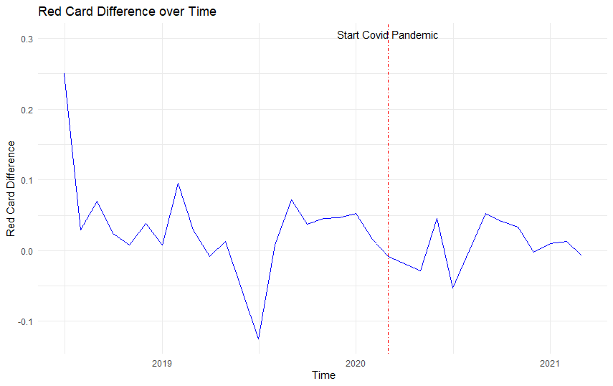

**Appendix 3b:**

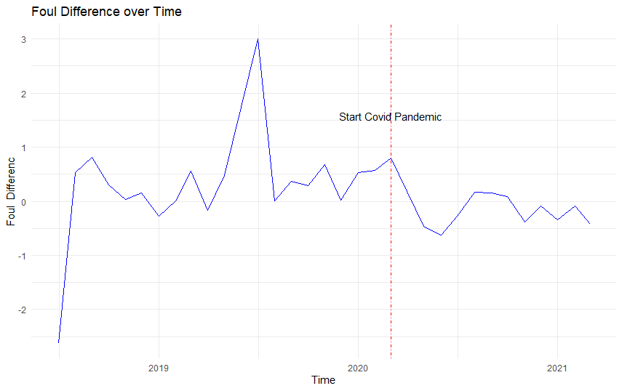

**Appendix 3c:**

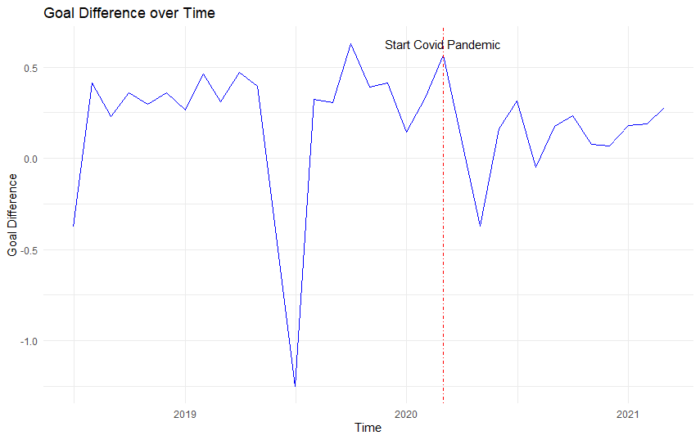

**Apendix 3d:**

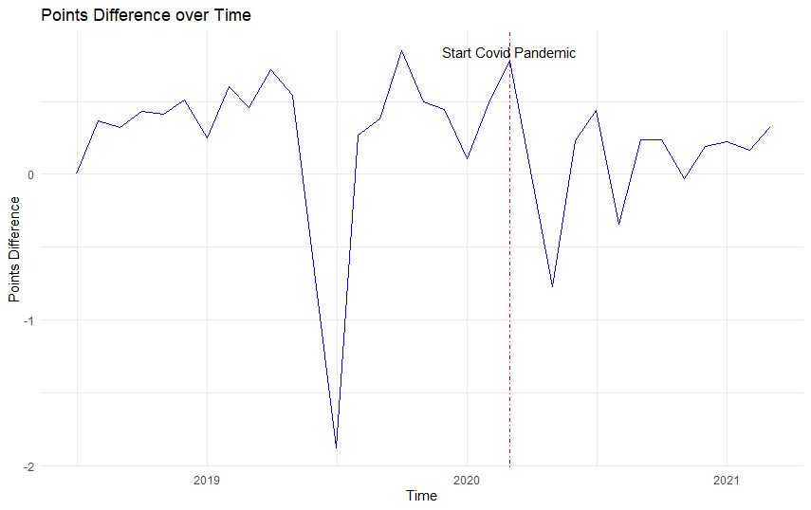

**Appendix 3e: Percentage points pre and post covid**

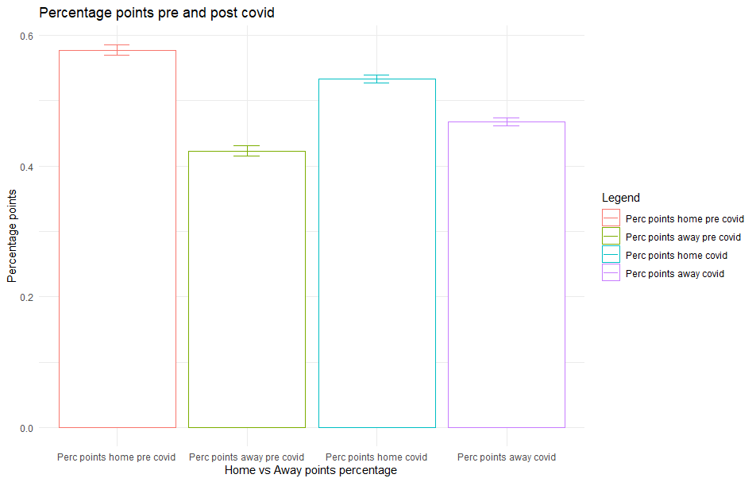

**Appendix 4a: Assumptions test indirect path**

Value p-value Decision

Global Stat 7.646553 0.10542 Assumptions acceptable.

Skewness 2.452351 0.11735 Assumptions acceptable.

Kurtosis 4.250997 0.03923 Assumptions NOT satisfied!

Link Function 0.940023 0.33227 Assumptions acceptable.

Heteroscedasticity 0.003182 0.95502 Assumptions acceptable

**Appendix 4b: assumption test direct path Points Difference**

Value p-value Decision

Global Stat 442.7895 0.000e+00 Assumptions NOT satisfied!

Skewness 43.0247 5.405e-11 Assumptions NOT satisfied!

Kurtosis 396.1679 0.000e+00 Assumptions NOT satisfied!

Link Function 3.0012 8.320e-02 Assumptions acceptable.

Heteroscedasticity 0.5957 4.402e-01 Assumptions acceptable.

**Appendix 4c: assumption test direct path Goal Difference**

Value p-value Decision

Global Stat 253.05579 0.00000 Assumptions NOT satisfied!

Skewness 0.75124 0.38608 Assumptions acceptable.

Kurtosis 248.47293 0.00000 Assumptions NOT satisfied!

Link Function 3.82617 0.05046 Assumptions acceptable.

Heteroscedasticity 0.00545 0.94115 Assumptions acceptable.

**Appendix 5a: Normality plot indirect path** 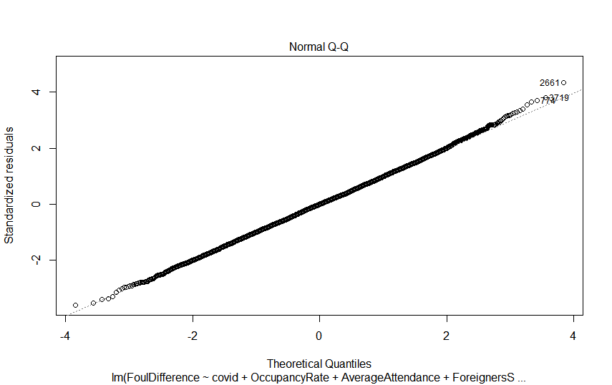

**Appendix 5b: Homoscedasticity indirect path**

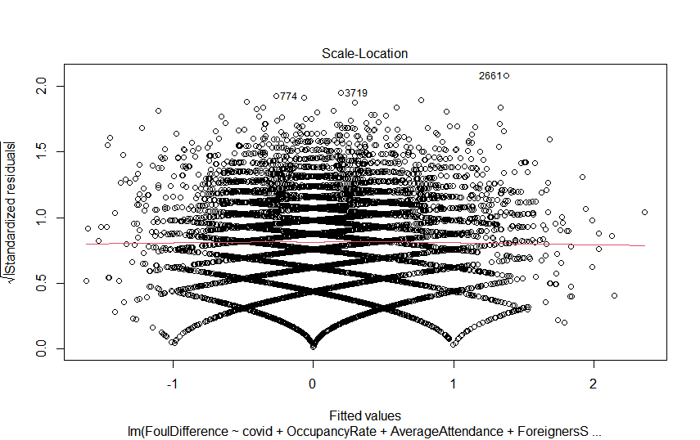

**Appendix 5c: normality direct path Goal Difference:**

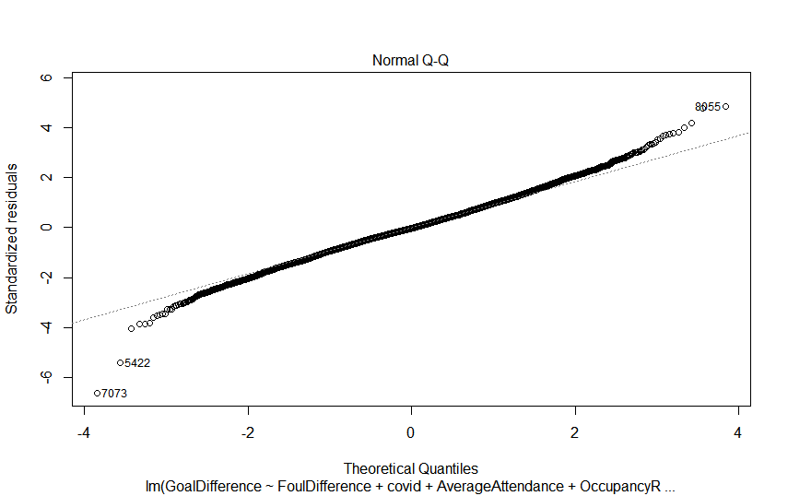

**Appendix 5d: Homoscedasticity direct path Goal difference**

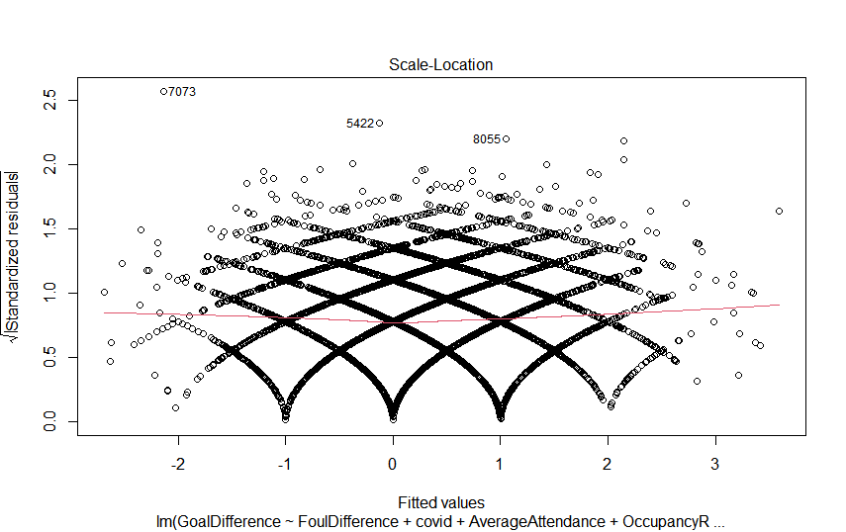

**Appendix 6a: Normality direct path Points difference**

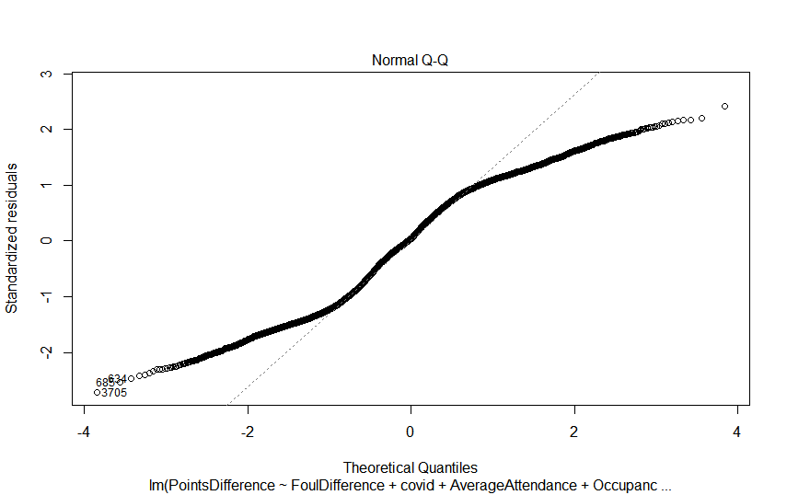

**Appendix 6b: Homoscedasticity direct path Points difference**

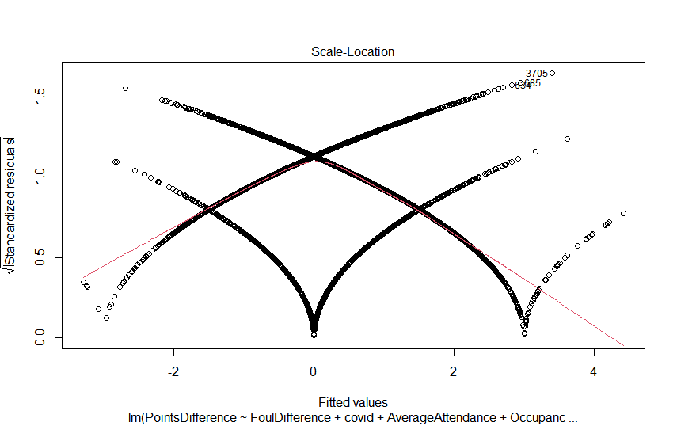

**Appendix 7: Correlation table**



Appendix 8a:**VIF table goal difference** 

**Appendix 8b:** **VIF table points difference**



1. 2 https://en.wikipedia.org/wiki/Video_assistant_referee
2. <https://projects.fivethirtyeight.com/soccer-predictions/>
3. https://www.football-coefficient.eu/money/
4. https://www.skysports.com/football/news/11661/11358620/the-cost-of-relegation-what-is-the-financial-impact-of-dropping-out-of-the-premier-league